# **MINI PROJECT**

**TalkOn – Bringing the World Closer**



**Institute of Engineering & Technology**

**Submitted by-**

Abhinandan Padmakar Pandey (181500008)

Harshit Pandey (181500256)

Harshit Arya (181500251)

**Supervised By*: -*** Mr. Vaibhav Diwan (Technical Trainer)

# **Department of Computer Engineering & Applications**

# 

**Contents**

1. **Introduction 3**
   1. General Introduction to topic **3**
   2. Hardware Requirements **3**
   3. Software Requirement **3**
2. **Problem Statement 4**
3. **Objectives 5**

**4. Implementation Details 6**

1. **Screenshots 38**
2. **Certificate 66**

# **Introduction**

# **1.1 General Introduction to topic**

We create an android social media application known as *TalkOn*. We choose the Android platform because it is easy to access and available everywhere. In this application, the user can log in using their email id. It is like Facebook or Instagram. We also connect our android application *TalkOn* to the database as there is a feature of sharing photos. For that, we are using the *Google Firebase* database. Why only Firebase? Why not others? The reason is that Google Firebase is one of the best open Google databases and it also provides lots of facilities like APIs and Machine Learning tools. It is a good choice. The looks of our application is inspired by other popular social media applications like Facebook, Instagram, etc. From this application, we can communicate through chat with friends. We can add friends as well in this application. Well, it also help us understand the core concept of android development and Katlin programming language. In this pandemic era of novel coronavirus when people are maintaining social distancing, a physical barrier is being created, this application could help people to come closer not physically but virtually.

# **Hardware Requirements**

* Android Operating System
* Min 2GB RAM (Memory)

# **1.3 Software requirements**

* Desktop or Smartphone
* Android Studio
* Internet Connection

**Problem Statement**

As we all knew that on 11 March 2020, WHO declared Novel Coronavirus Disease (COVID-19) outbreak as a pandemic and reiterated the call for countries to take immediate actions and scale up the response to treat, detect and reduce transmission to save people’s lives. In this regard, on 24 March 2020, the Government of India under Prime Minister [Narendra Modi](https://en.wikipedia.org/wiki/Narendra_Modi) ordered a nationwide lockdown for 21 days. Due to the lockdown and social distancing, a physical barrier is being created. So, we need a MADE IN INDIA method to interact with society as well as maintain the protocols of lockdown.

# **Objective**

To solve this problem we create a MADE IN INDIA social media application and we call it *TalkOn*. Our application *TalkOn* is able to provide the following features to the users, which are

* Login/signup using email id
* Search your friends
* Follow friend
* Post your photos
* Like your friend’s photos

# **Implementation Details**

* **Register / Sign Up –**

This is our application’s sign up page. From this page we can register our self-using the email id. Email id should be unique foe every user. The registered details will be stored in the Firebase Database. It will help us in future while log in. Because of the stored data, we will be able to log in any time using our email id.

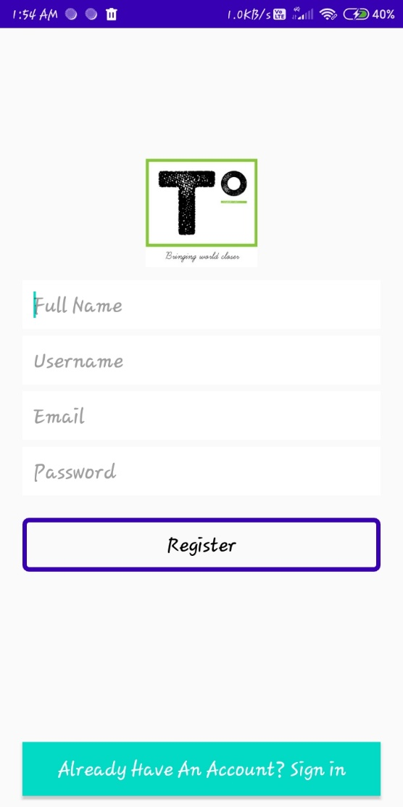

* “*Full Name*”:- Here user needs to enter his/hir full name.
* “*Username*”:- User needs to enter the username he/she prefer to use
* “*Email*”:- User needs to enter the unique email id. If the email is is already used, then user may not be able to register.
* “*Password*”:- Password must be atleast of six digits.
* “*Register*”:- Using this button, user will be able to register successfully, and the data will transfer to the Firebase Realtime Database.
* “*Already Have An Account? Sign in*”:- Using the button user can directly go to log in page.

Here is an example –

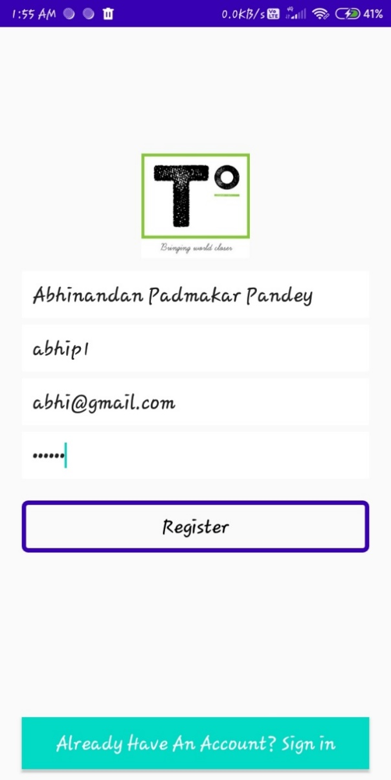

Here is the screenshot of the details in the Firebase Realtime Database:

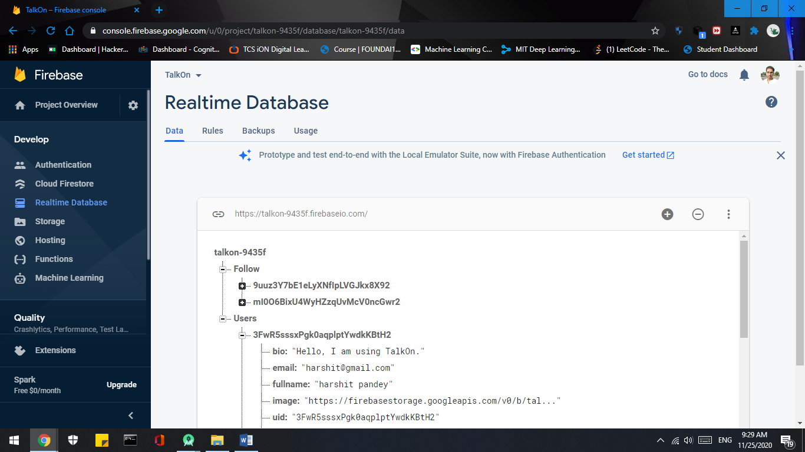

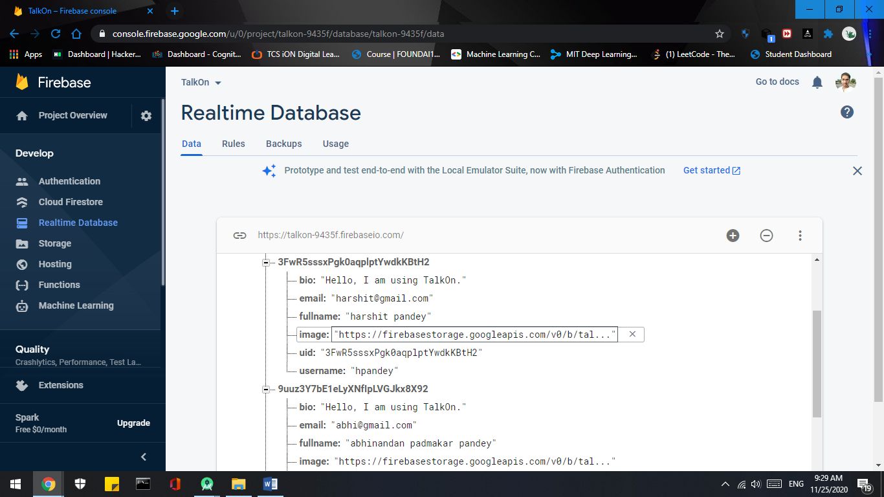

* **Log In / Sign In –**

This is our application Log in page. With this help, user can log in any time by entering the unique email address and its password. While registering, the user information was stored on Firebase Realtime Database. Through this Database we can check the details enter by the user while login. Here is the user interface of the log in page.

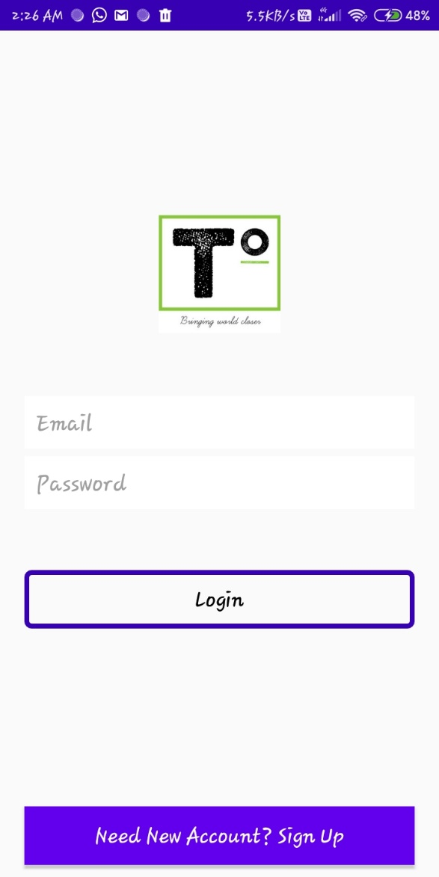

* “*Email*”:- Here, user needs to enter its email id which was provided by the user while registering the account.
* “*Password*”:- Here, uses needs to enter the password whish was provided by the user while registering the account.
* “*Login*”:- With the help of this button, user can let the application check the details. If the details provided above are correct then user can log in.
* “*Need New Account? Sign Up*”:- With this button, if the user do not have any account then he can directly go to the Sign up /Register page and can register them.

Here is the example of it –

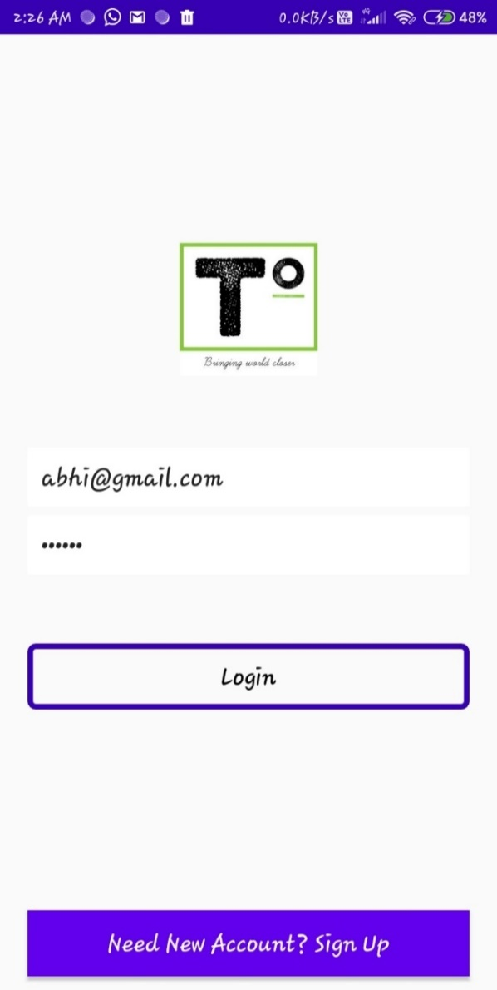

* **Log Out / Sign Out –**

User can log out him or her by going to Account setting (“*Edit Details*”) which is in profile page in application. So, first user needs to go to profile. There is a button called “*Edit Details*” which is actually account setting page. There is a button called “*Log Out*”. With help user can log out from the application.

Here is the example –

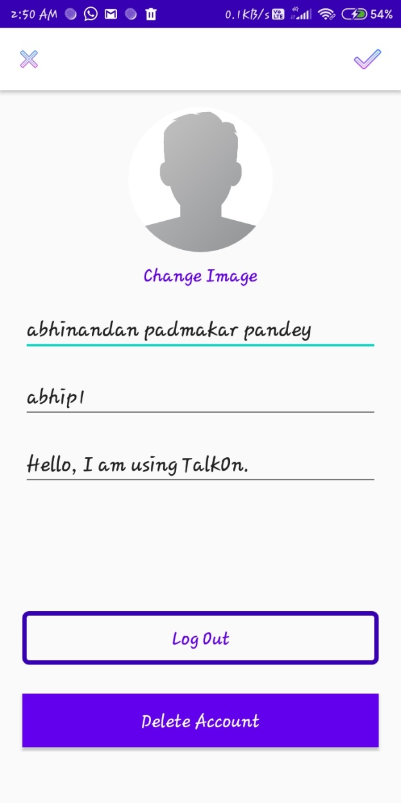

* “*Log Out*”:- This is a button. It provide the ability of log out. With the help of this button user can log out from the application.
* **Home -**

With the help of home page, user can view the posts timeline of the people he is following and also itself. Here, not only user can view, but here he or she has the facility of giving their response by liking the posts and commenting on them. Only friends can view user posts. No one else can view it. And same goes for comments as well.

Here is how it looks –

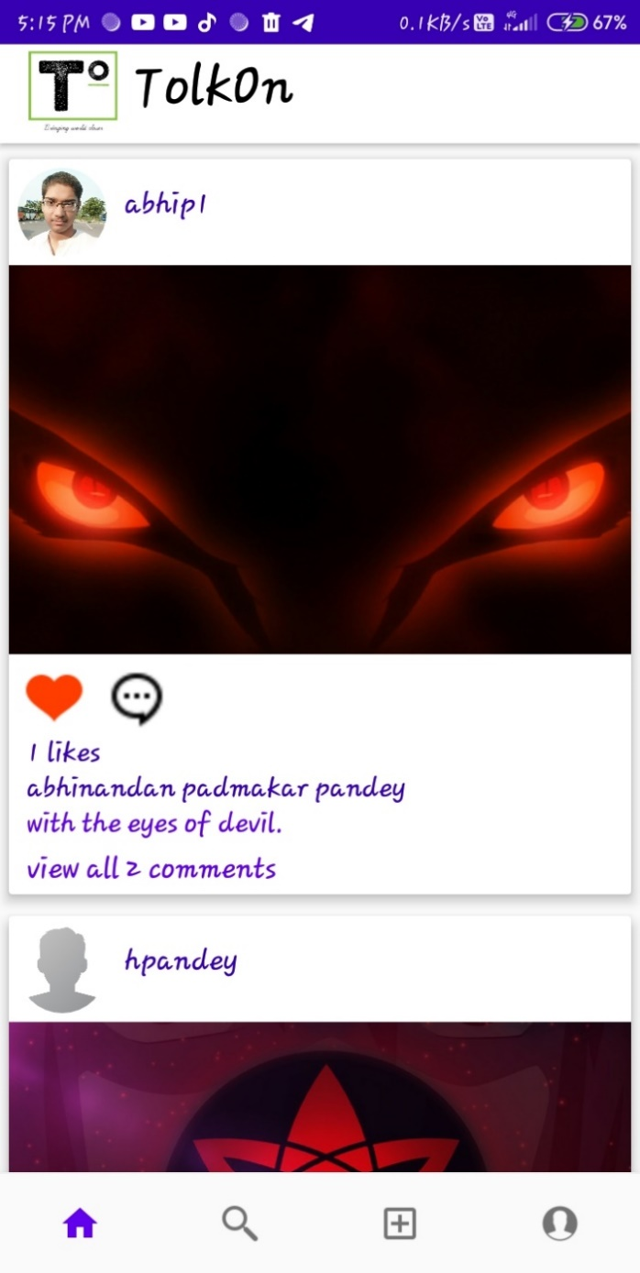

*  :- With the help on heart button, user can like the post of its friend and give its reaction.
* :- With the help of comment button, user can provide thir thoughts and comment on the post. By pressing it user will move to the comment page.



* “*1 like*”:- Here, user can view the total number of like on his post by his friends.
* “*abhinandan padmakar pandey*”:- With this, user can view the full nmae of his or her friend and can knew whose post this is.
* “*view all 1 comment*”:- By clicking on this button, user can see all the commnet on the postof his friends. And even he or she can comment from ther on the post.

Here is what it lock like -

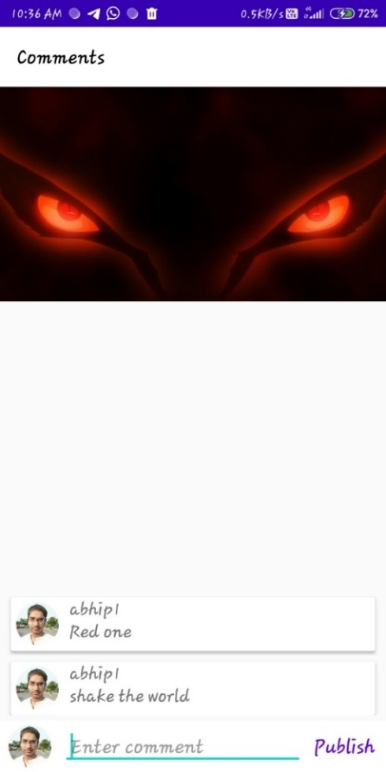

* “*Enter comment*”:- This is a thype of editable text. By lcicking here, user can write his or her cammens and provide there thoughts.
* “*Publish*”:- By the help of this button, user can publish its commnets and others will be able to see his or her comments.

Here some other images of the Home Page –

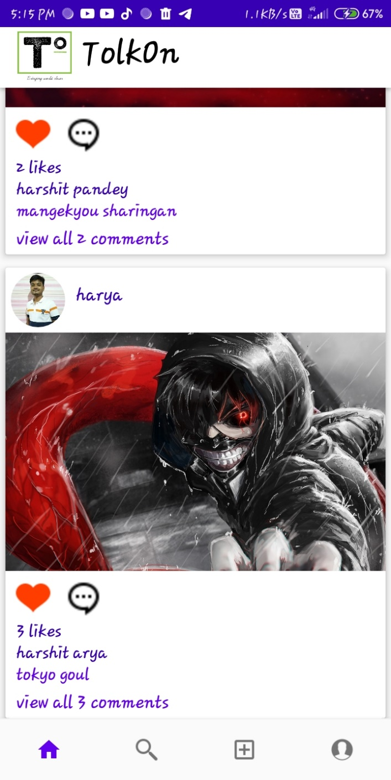 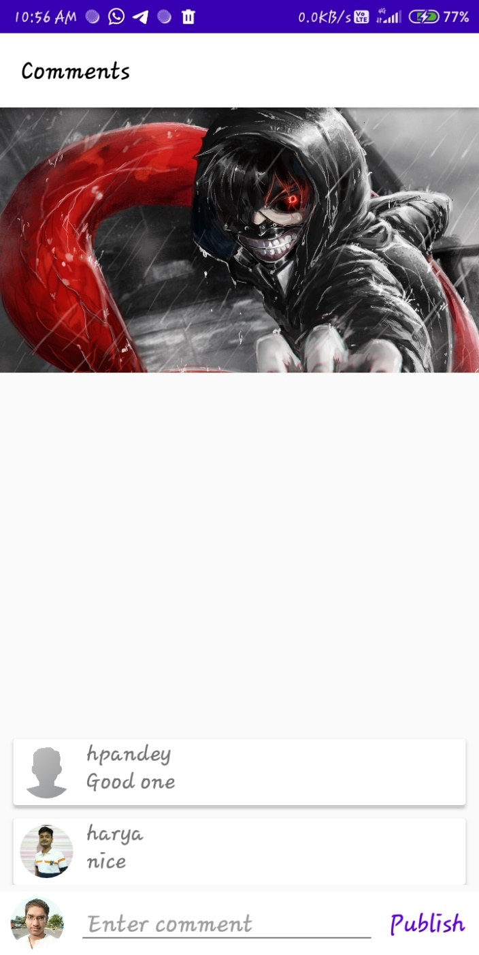

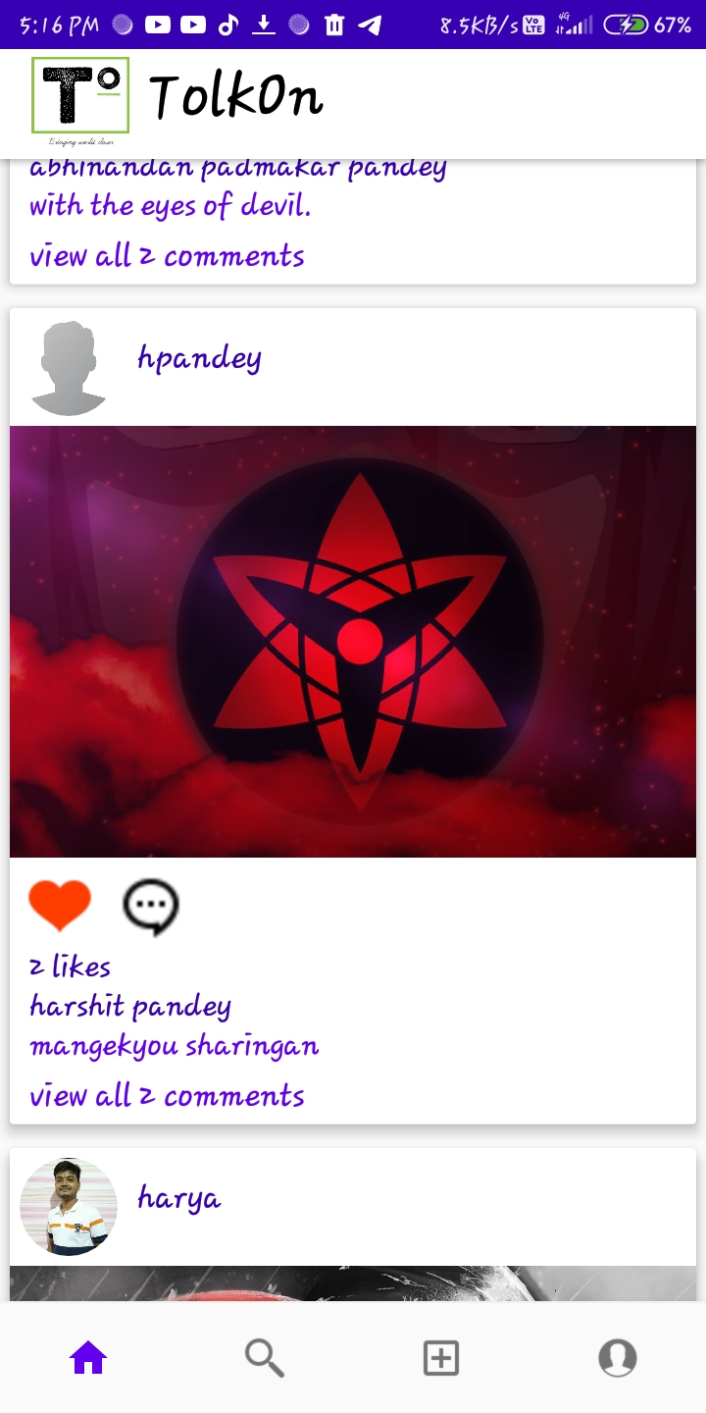 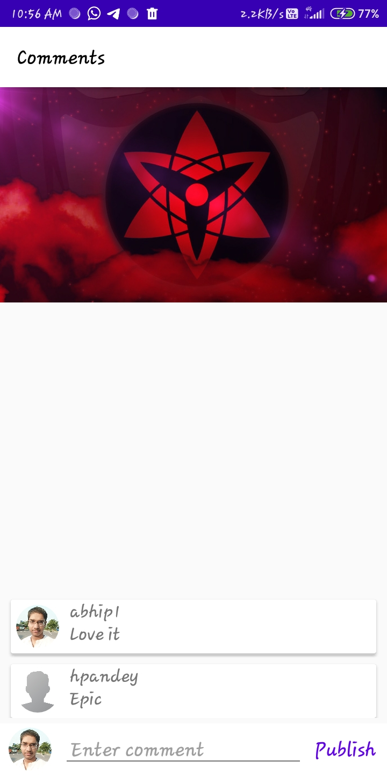

* **Search –**

Search Page is one of the best features of our application. With the help of this page, user is able to search other peoples with their **usernames**, which they provided at the time of registration. This page not only show the users but it also provide the option to make them your friend and allow the facility of follow and unfollow the search user.

Here is how it looks –

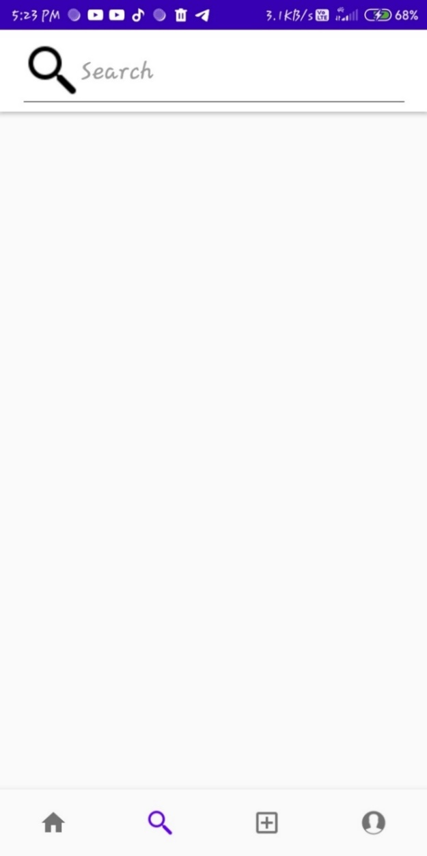

* “*Search*”:- This is a type editable text. With the help of this editable text user can search other users by typing the username of other users.
* It search alphabetically, so if the user type “h” then all the users, with the username starting with “h”, will come.
* This editable text bar is not case sensitive. Means, if the user type an alphabet then it will show all the users with username starting with capital as well as small of the same alphabet.

Here are some examples of it –

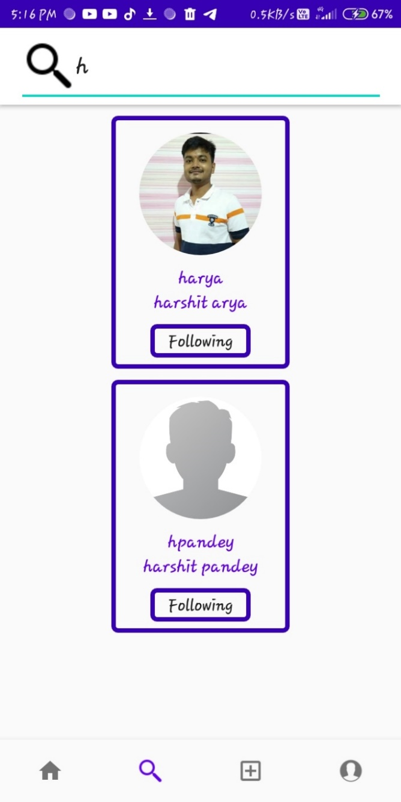 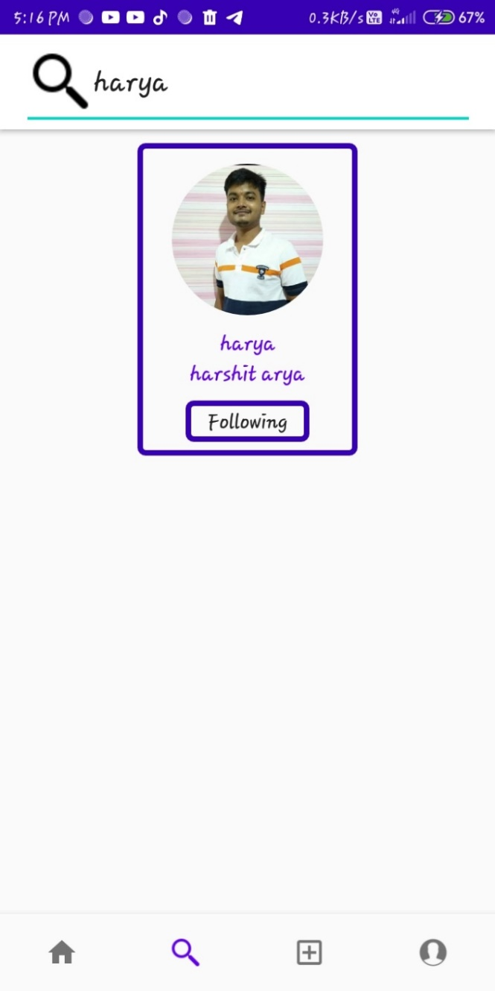

* “*harya*”:- Here, user will see the **username** of the user whom he or she is searching.
* “*harshit arya*”:- Here, user has the facility of viewing the **Full name** of the user whom he or she is searching.
* “*Following*”:- This button provide the facility of **Follow** the user he or she is searching about or even **unfollow** the user by clicking the “Following” button.
* **Add post –**

This is one of the main feature of our application. By clicking the add icon  , user can directly jump to the Add Icon Page and can select the image. User also has the facility in which he or she can crop the images.

All the posts by the users are stored in Firebase Storage. With its help, other users can also see the posts if they are friends.

Here is how add post page looks –

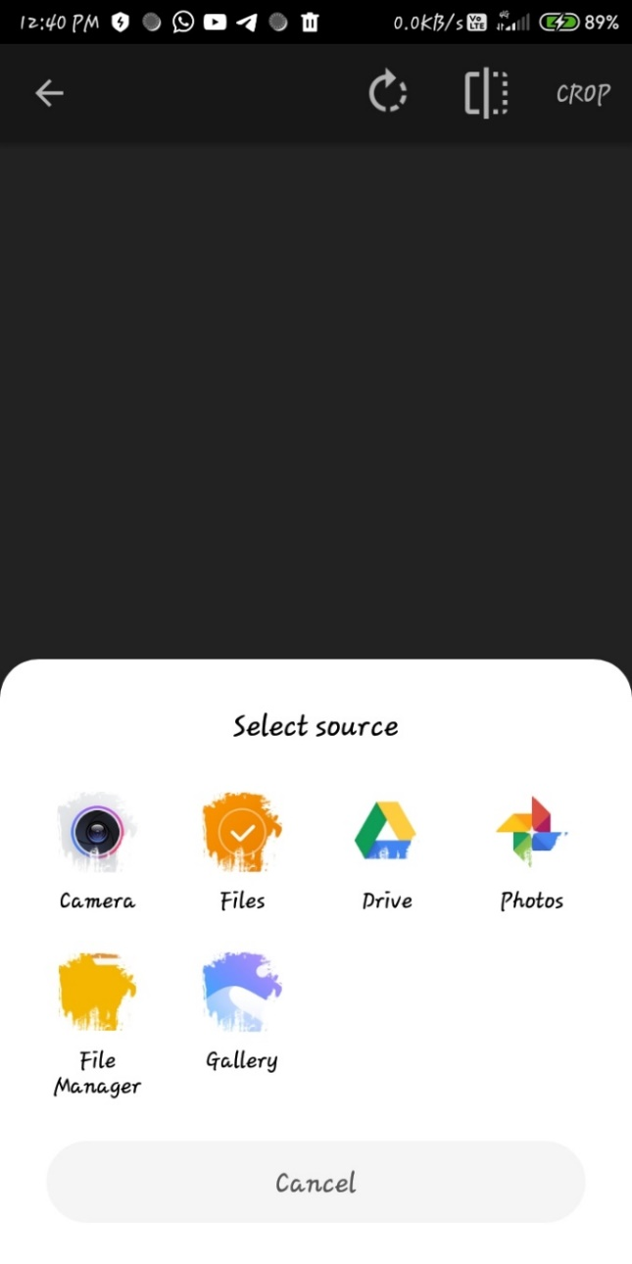

After selecting the image this is how it looks –

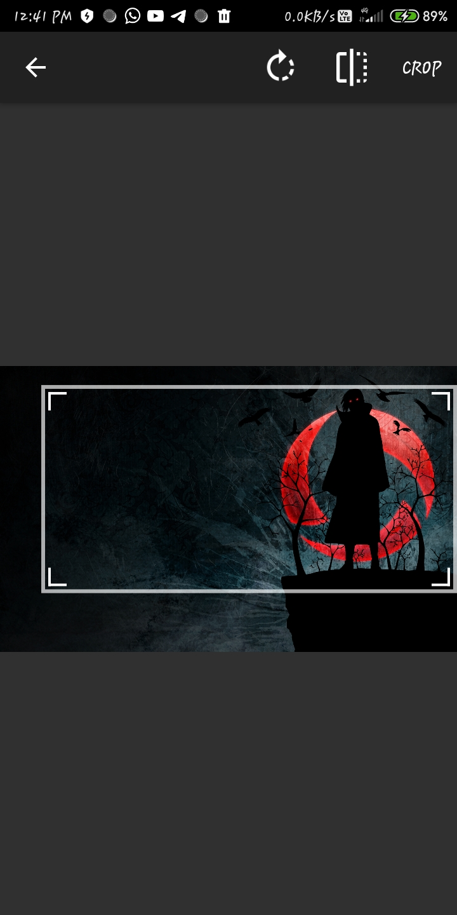

Here, user has the facility of cropping the image. After selecting the portion of image, user needs to press “***CROP***” button to complete the selection of image.

After the selection and cropping the image, user needs to enter the description of the image.

Here is an example of it –

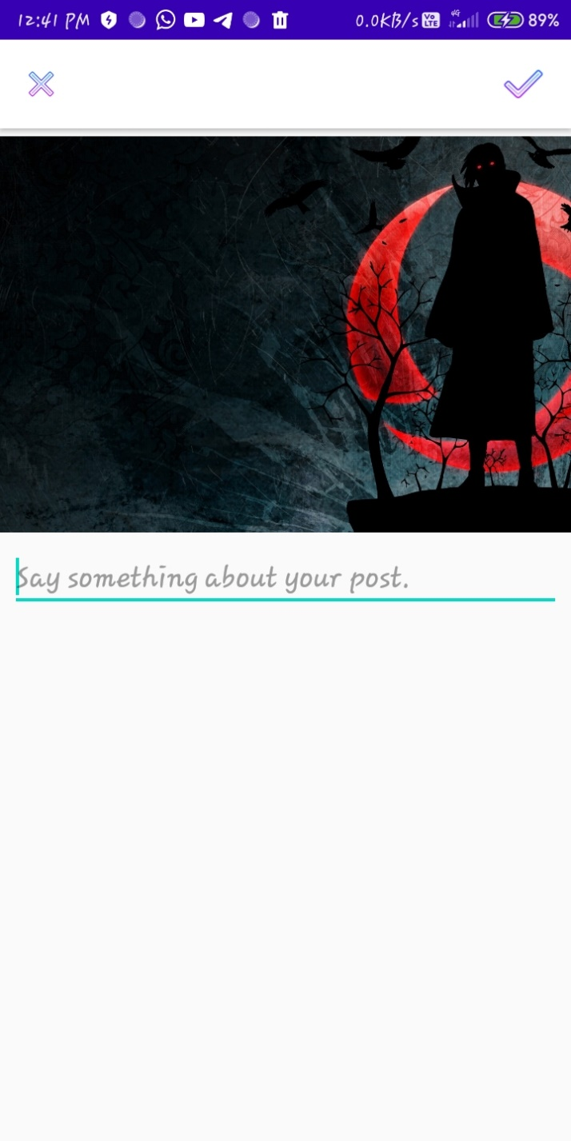

* “*Say something about your post*”: - This is a type of editable text. Here user can type the description of his or her post. It is mandatory to add the description of the post. The description will also be stored in the Firebase Realtime Database.

Here is an example of it –

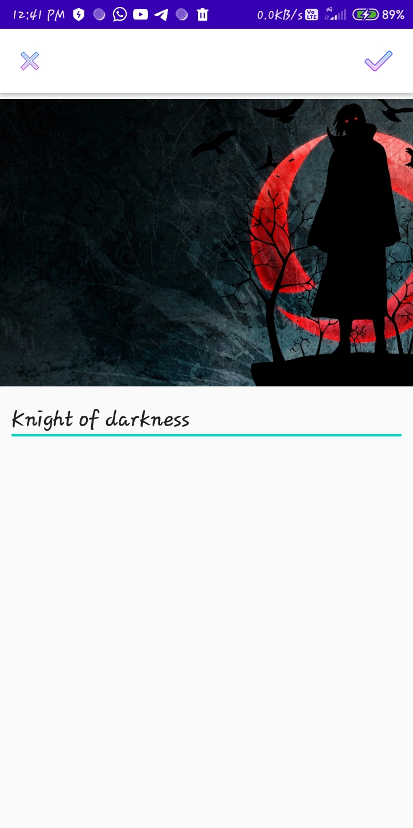

*  : - With the help of this button, user can confirm the description of the post and completing the posting process.

After adding the description user must click  button for confirming the post.

* **Profile –**

With the help of Profile Page, user has the ability to check the details they provided at the time of registering the account. Here, user can also has the facility of changing the account details. User can change his or her Full name, username, and bio and also can change the profile picture.

Here is the screen short of it –

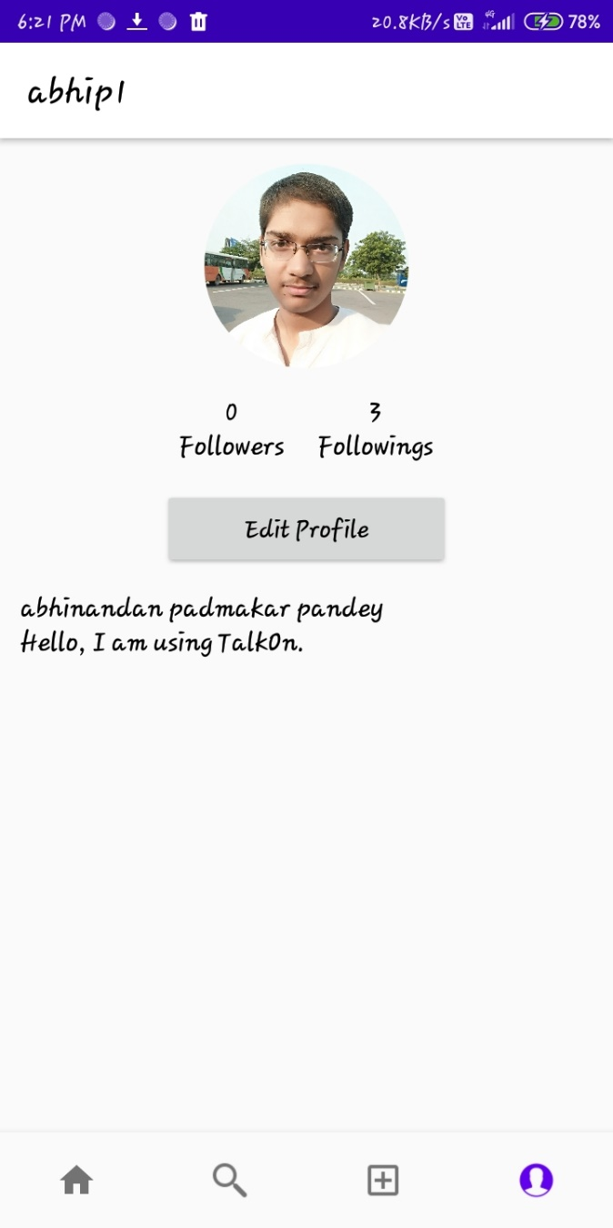

* “*abhip1*”:- Here, user can view its username. Above screen short is just an example.
* “*abhinandan padmakar pandey*”:- This is the place were user can view its full name. Full name is given by the user at the time of registering.
* “*Hello, I am using TalkOn*”:- “*Hello, I am using TalkOn*” is the by default bio of the user. User can change it’s by default bio any time he wants.
* “*Followings*”:- will show the number of people you follow
* “*Edit Profile*”:- This is a type of button. By clicking on it, user can directly jump to Account Setting Page.

With the help of Account Setting Page, user can change its account details as well as, can add or change its profile image.

* **Account Setting –**

Account setting Page is one of our application main feature. With the help of it, user can change the details of its account any time he or she want. Also with the help of this page, user can add or change the profile picture in the application. This Account setting page also provide the facility of log out or you can say sign out and deleting the account.

Here are the looks of it –

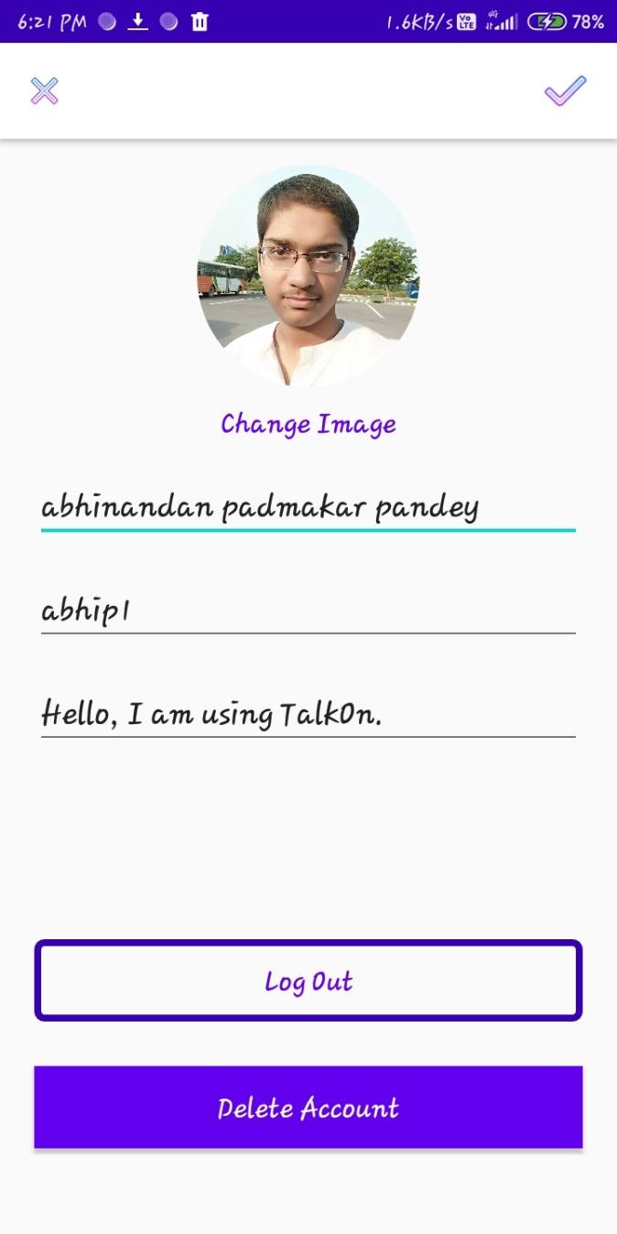

* “*Change Image*”:- By clicking on this button, user can add its profile picture and if already uploaded then he or she can change the profile picture.
* “*abhinandan padmakar pandey*”:- This is a type of editable text. Here, user can change its full name by replacing the old one and providing the new one.
* “*abhip1*”:- This is also a type of editable text. From here, user can change its user name. User needs to replace the old username with the new username.
* “*Hello, I am using TalkOn*”:- This editable text is actually the place of user bio. User can change its bio by replacing the old one with the new one.
* “*Log Out*”:- This is a button. It provide the ability of log out. With the help of this button user can log out from the application.
* “*Delete Account*”:- This is one of the sensitive feature of our application. By clicking on this button, user can erase its account whole details. Including posts and profile image. Users account will completely delete.
*  : - With the help of this button, user can confirm the changes done in account details and completing the posting process.

For saving the change, user needs to click on  button.

Before clicking on the  button, make shore that every column (i.e. Full name, username, and bio) is filled. If any of the column is empty then user cannot save the change details.

User can change or add its profile image by clicking on the “*Change Image*”. After clicking on this button user will jump to the selection page.

Here is the screen short of it –

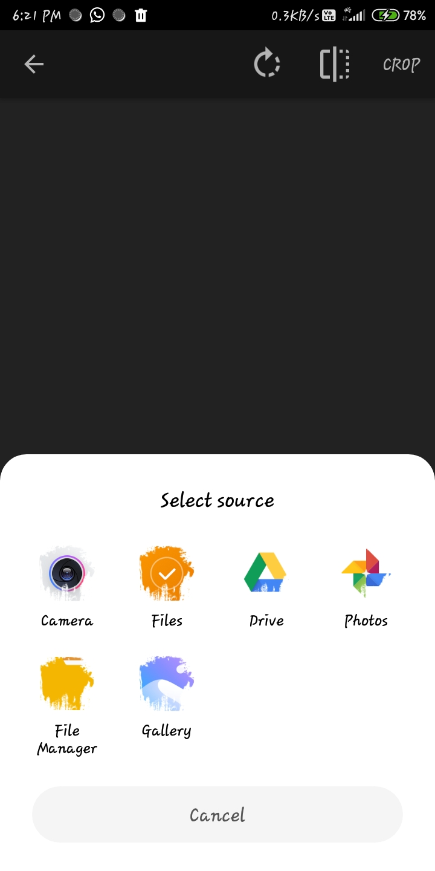

* **Like –**

Our application one of the feature is that user can react on the posts of its friends. By clicking on the like button (), below the post, at home page, user can give its reaction on post.

Here is how it looks –

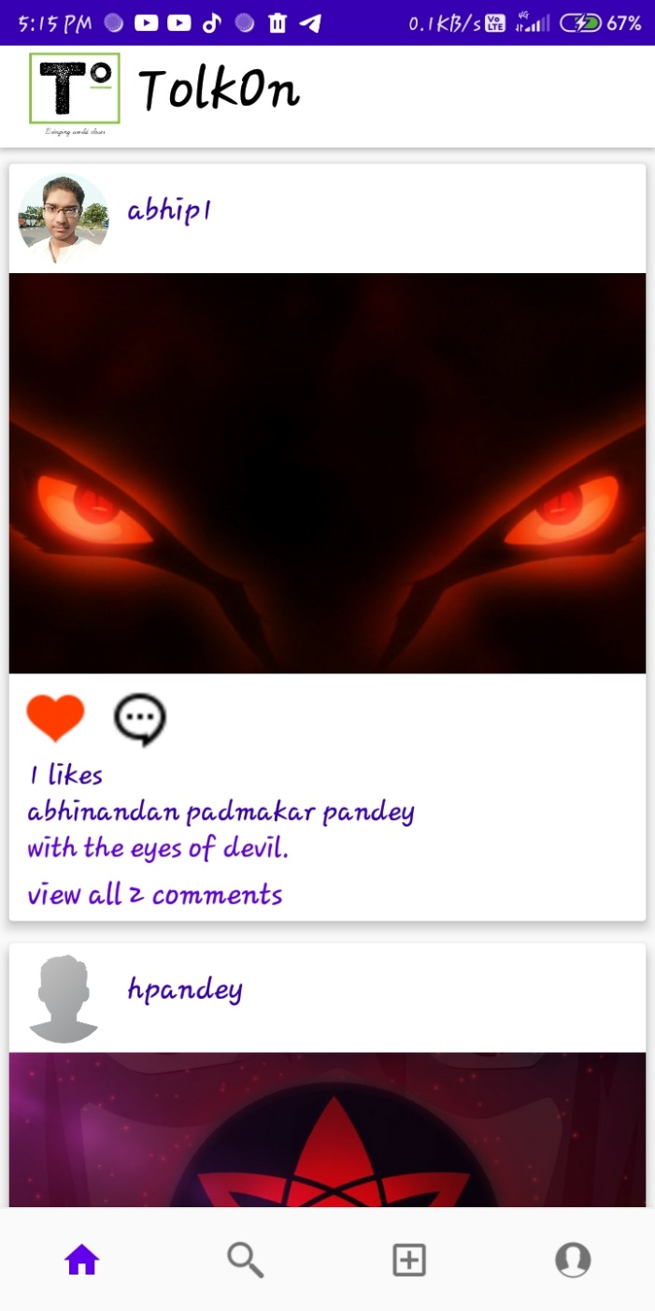

*  :- With the help on heart button, user can like the post of its friend and give its reaction.
* “*1 like*”:- Here, user can view the total number of like on his post by his friends.
* **Comment –**

User can also provide its thoughts as the reaction on the posts of its friends as well as itself. This can be done by clicking the comment button () below the post, at home page, user can commenting on the posts. Only friends of the user can view the comments.

Here is how it looks –

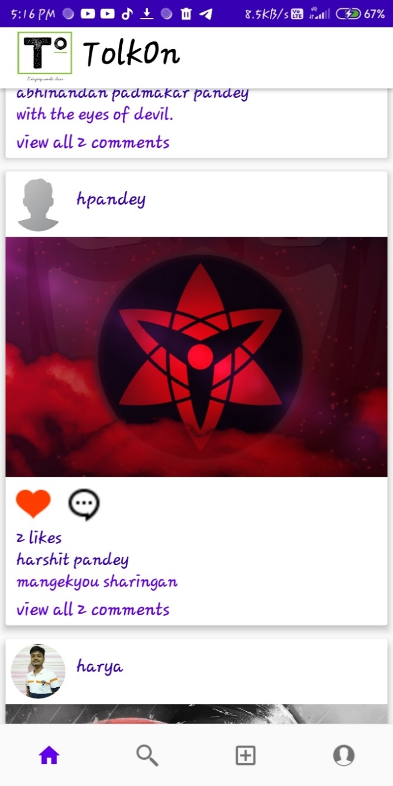

* :- With the help of comment button, user can provide thir thoughts and comment on the post. By pressing it user will move to the comment page.
* “*view all 2 comment*”:- By clicking on this button, user can see all the commnet on the postof his friends. And even he or she can comment from ther on the post.

Here is what it lock like -

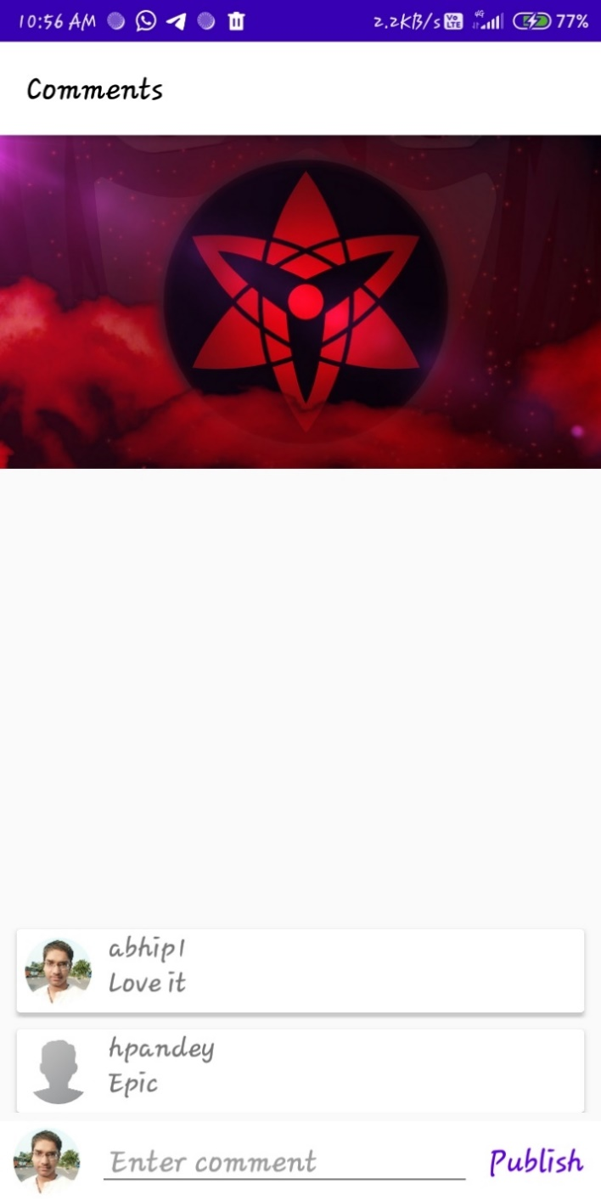

* “*Enter comment*”:- This is a thype of editable text. By lcicking here, user can write his or her cammens and provide there thoughts.
* “*Publish*”:- By the help of this button, user can publish its commnets and others will be able to see his or her comments.

Here some other images of the Home Page –

 

* **Follow Friend -**

In our application, user has the ability to follow and unfollow the other users. It is same as making another user its friend. Follow and unfollow can be done in the search page.

Here are some examples of it –

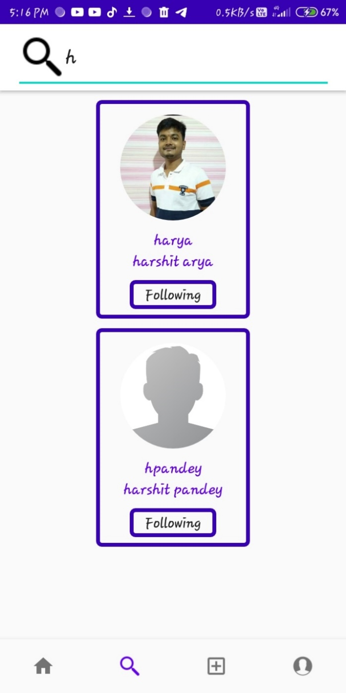 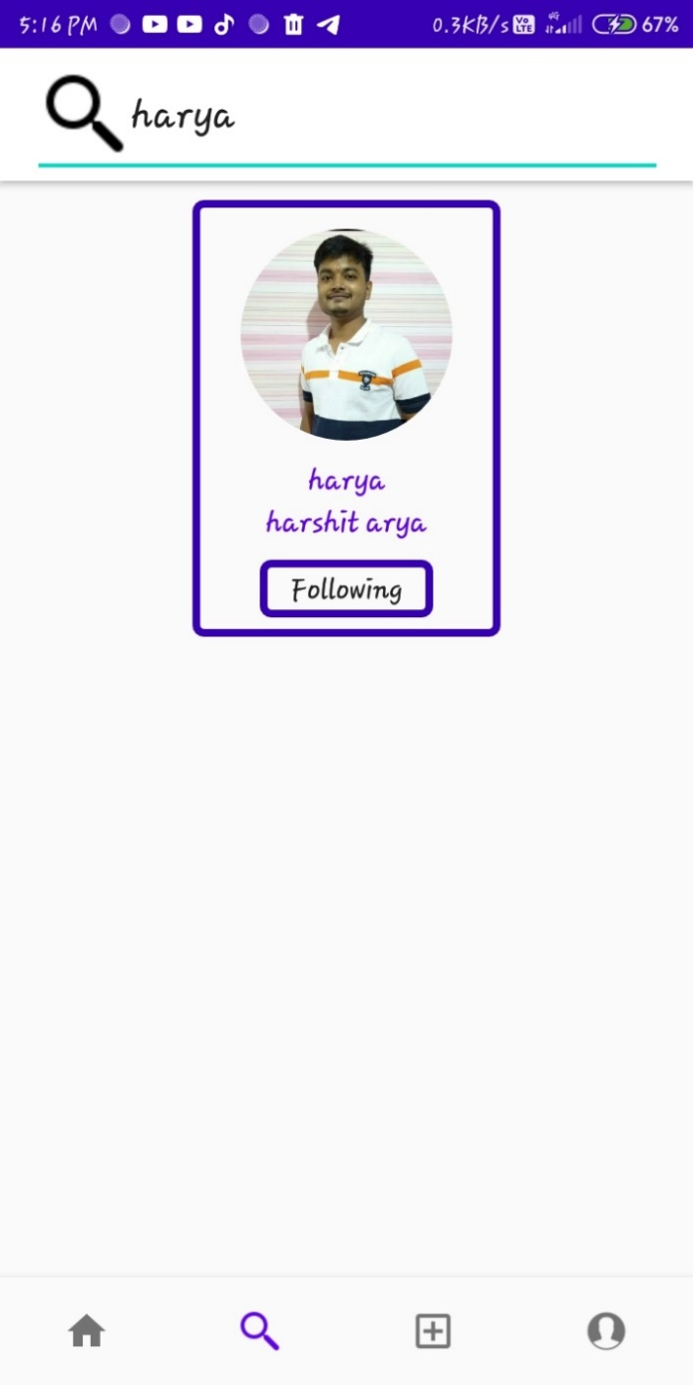

* “*Following*”:- This button provide the facility of **Follow** the user he or she is searching about or even **unfollow** the user by clicking the “Following” button.
* If user click on “***Follow***” button then the user can be follow the search user.
* If user click on “***Following***” button then the user can be unfollow the search user.

**Screenshots of Code**

* **Register / Sign Up –**
  + **User Interface**

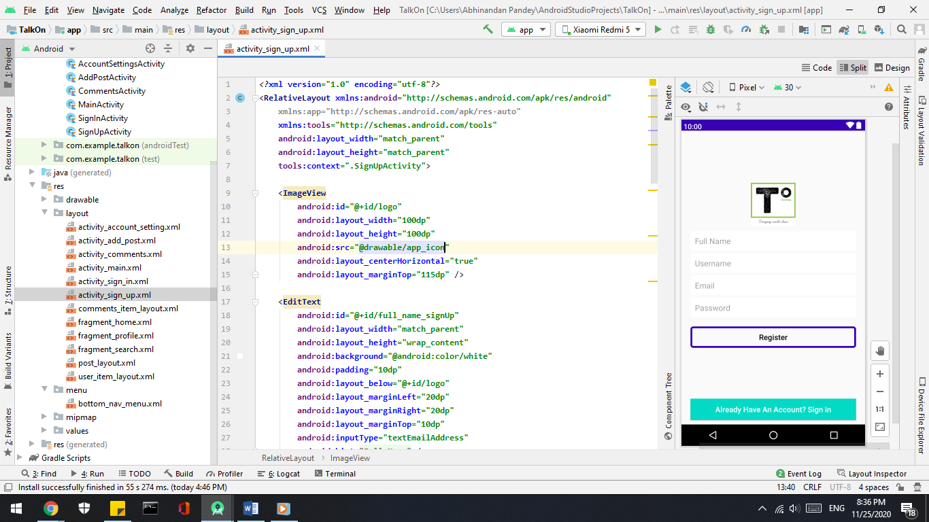

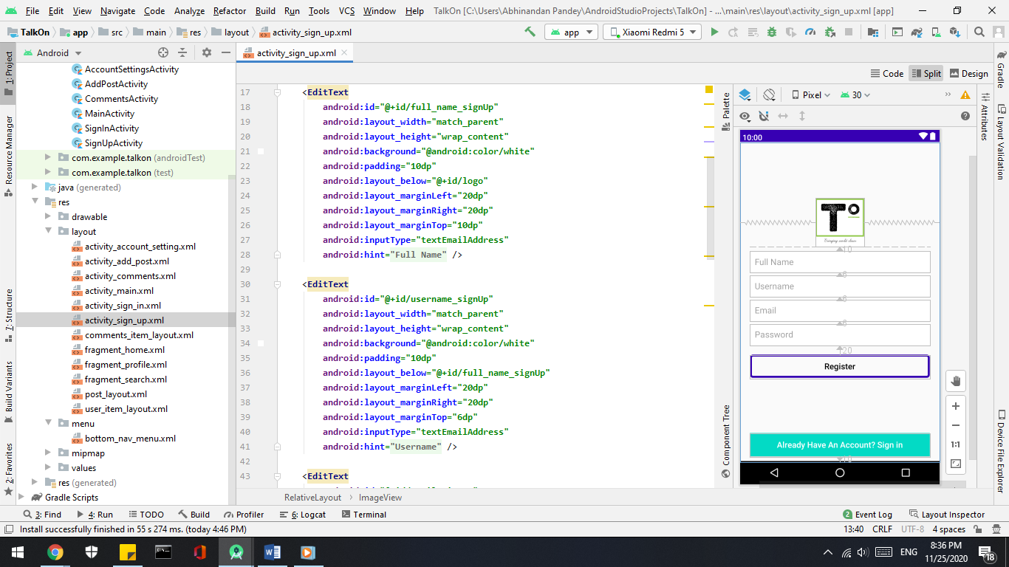

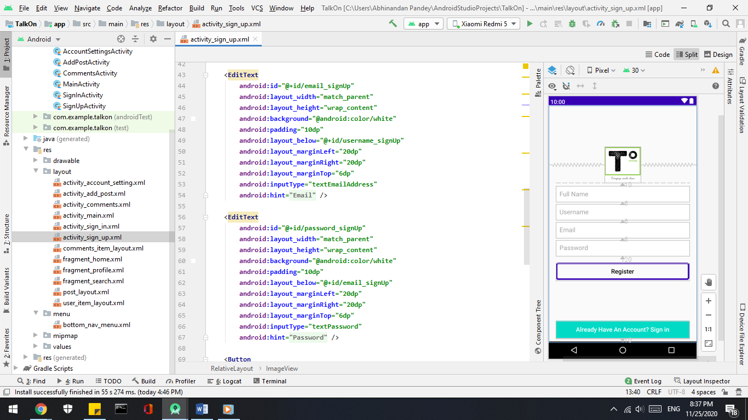

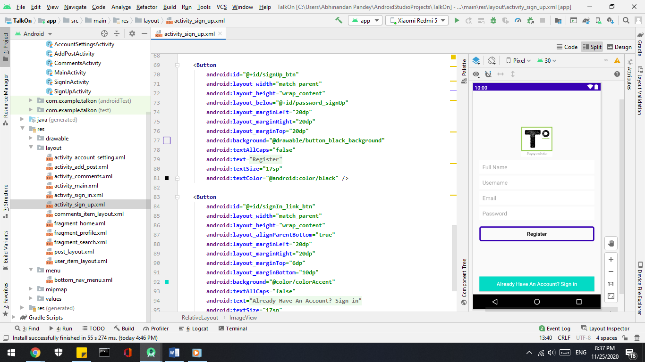

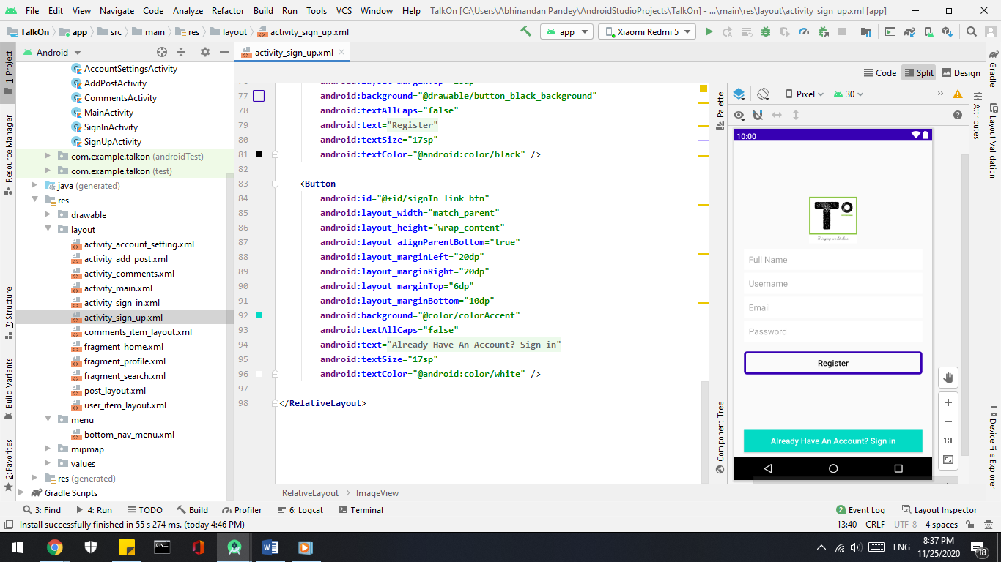

* + **Backend**

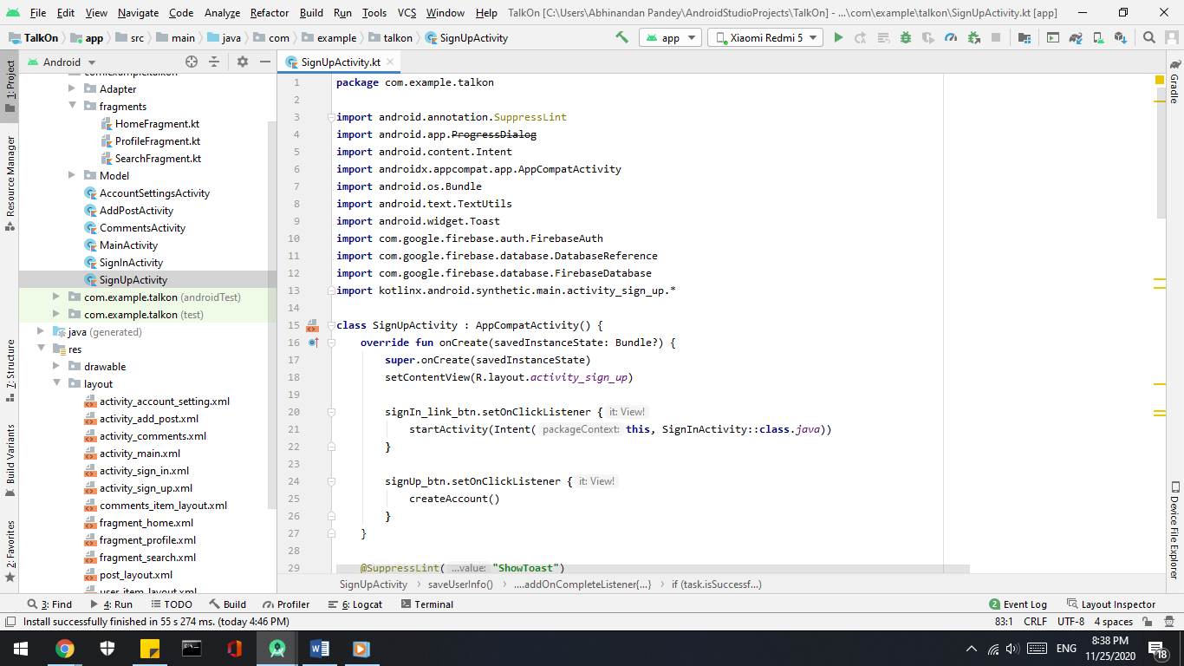

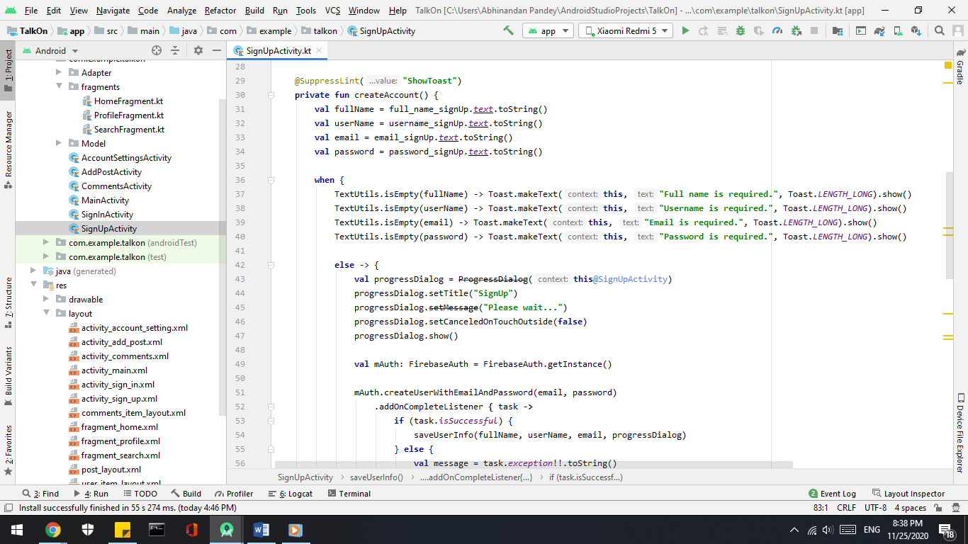

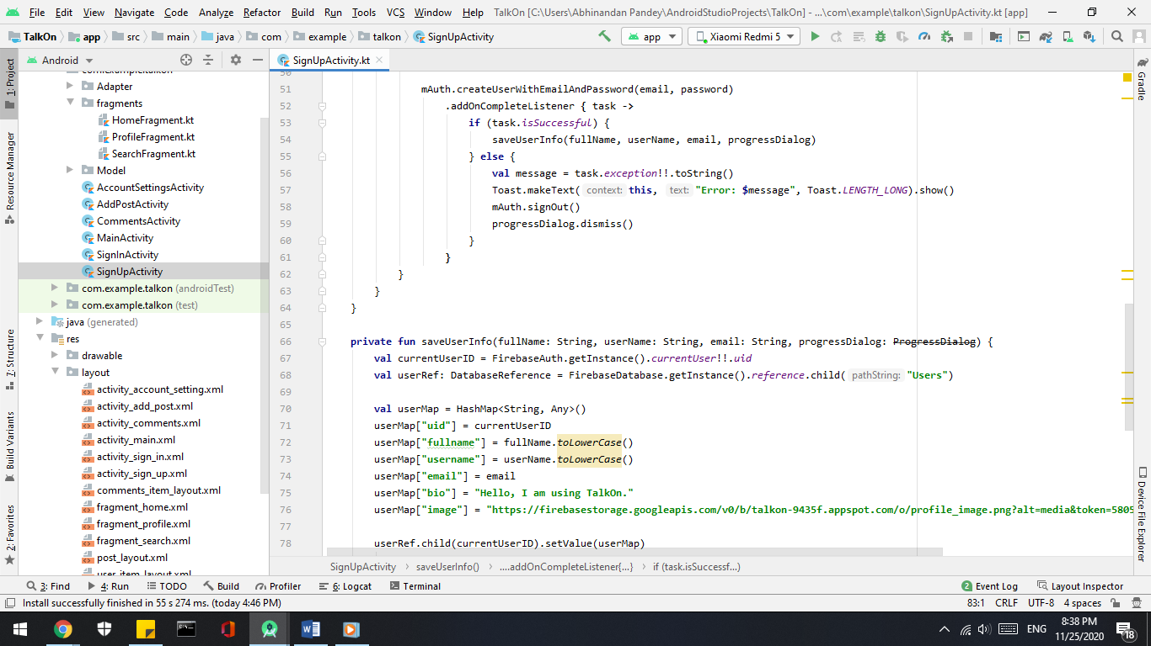

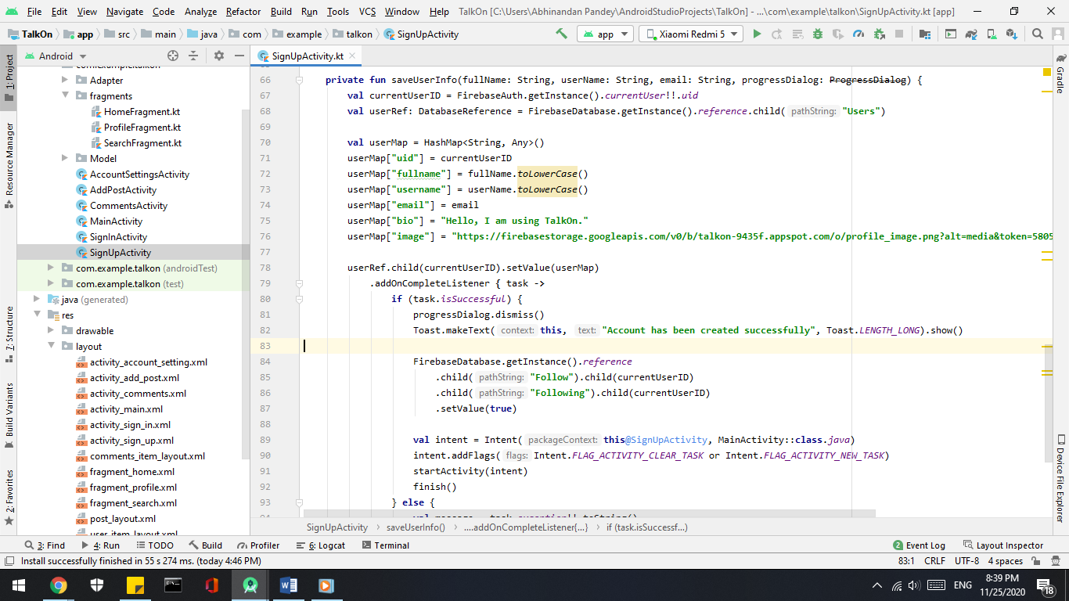

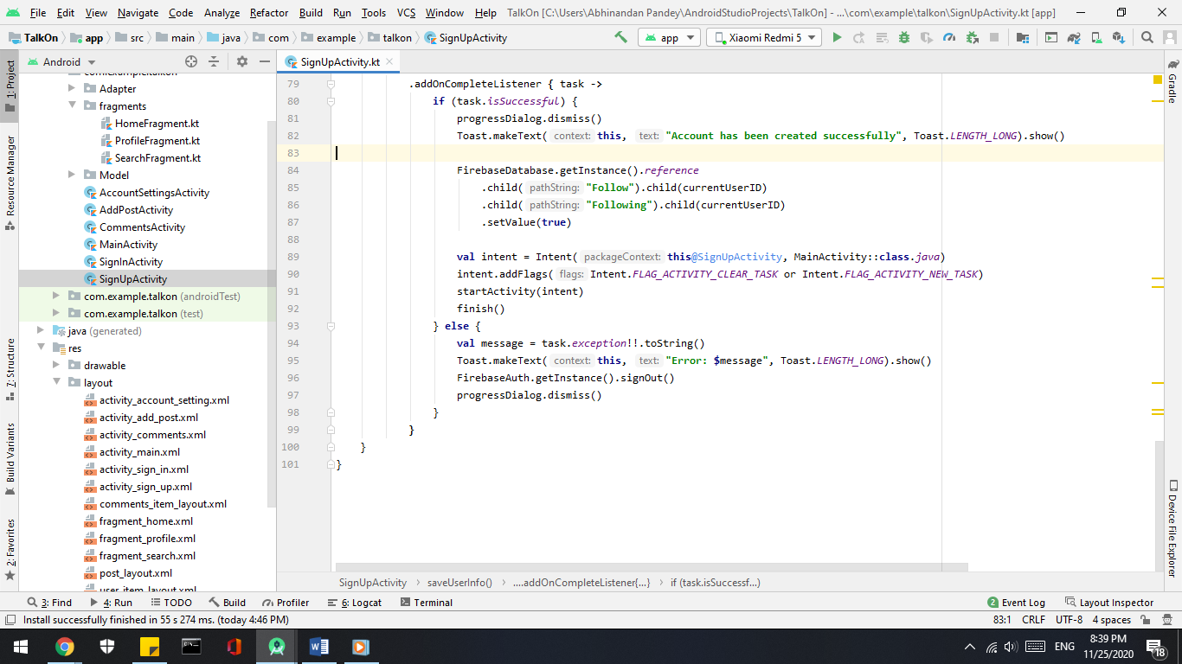

* + **Firebase**





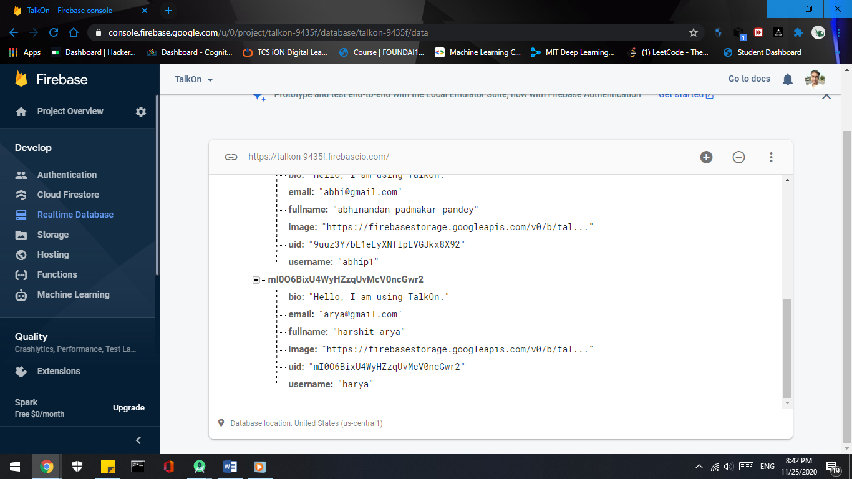

* **Log In / Sign In –**
  + **Frontend**

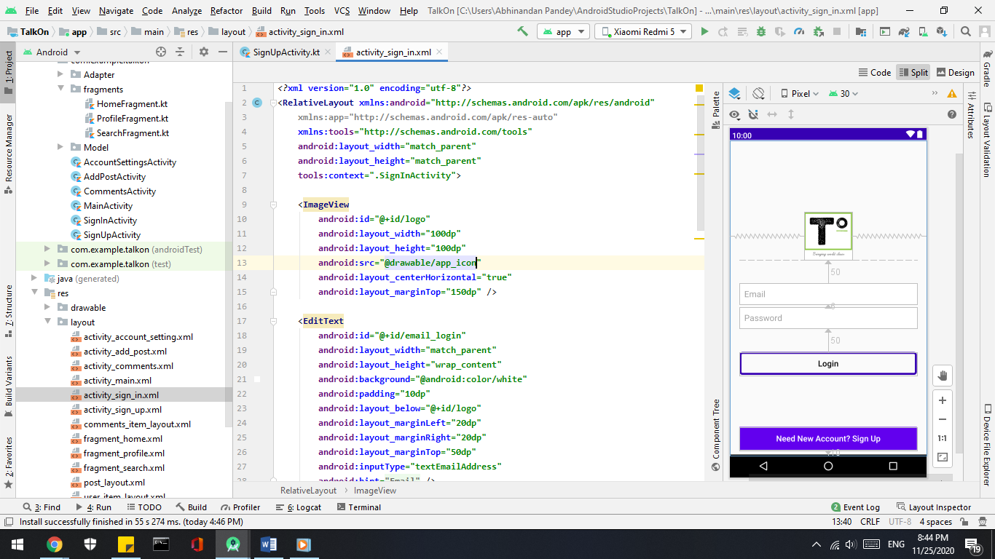

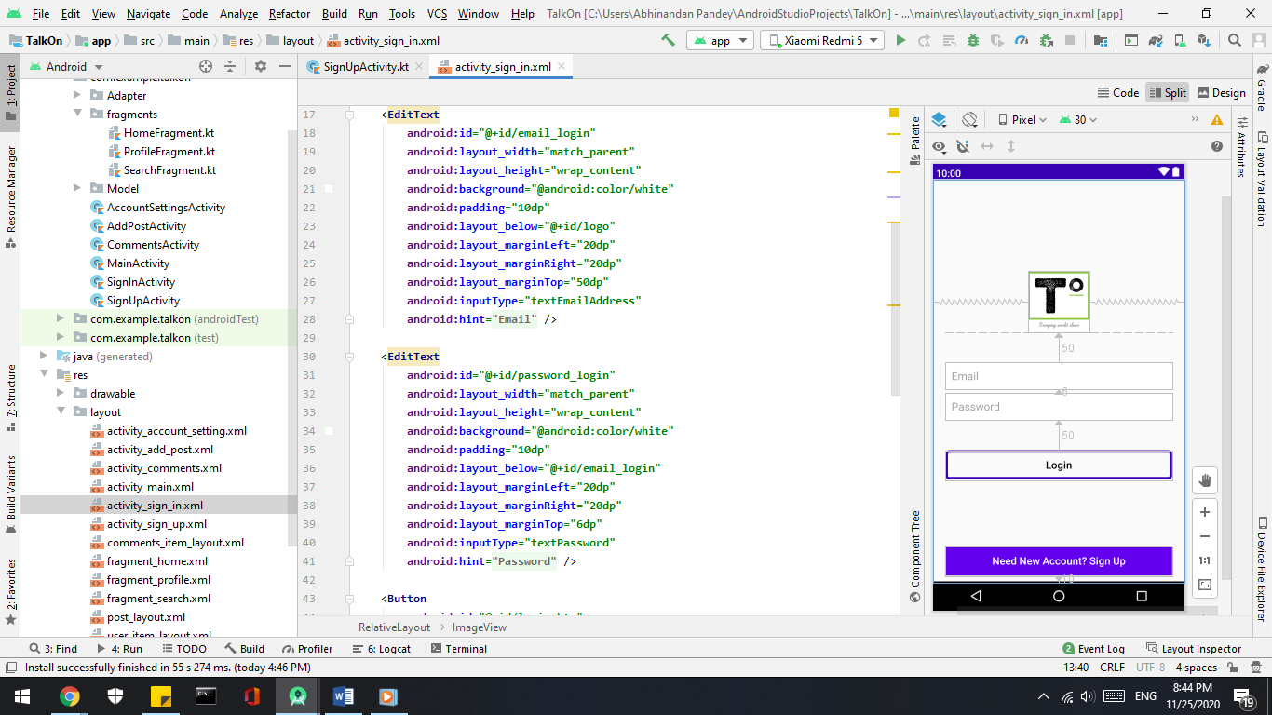

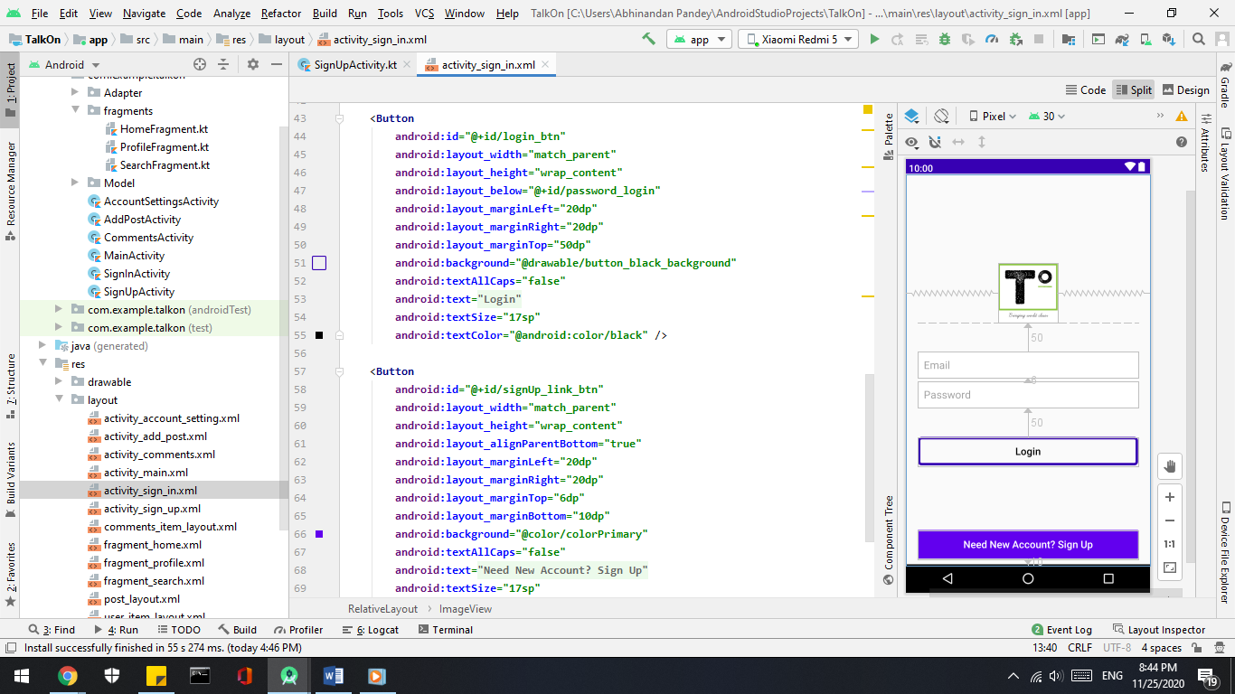

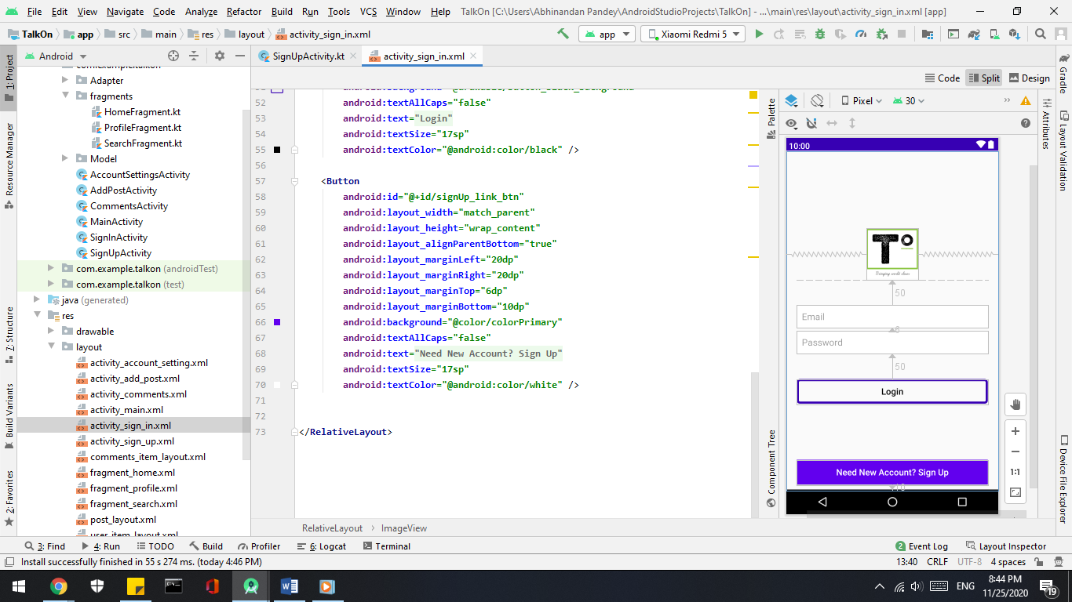

* + **Backend**

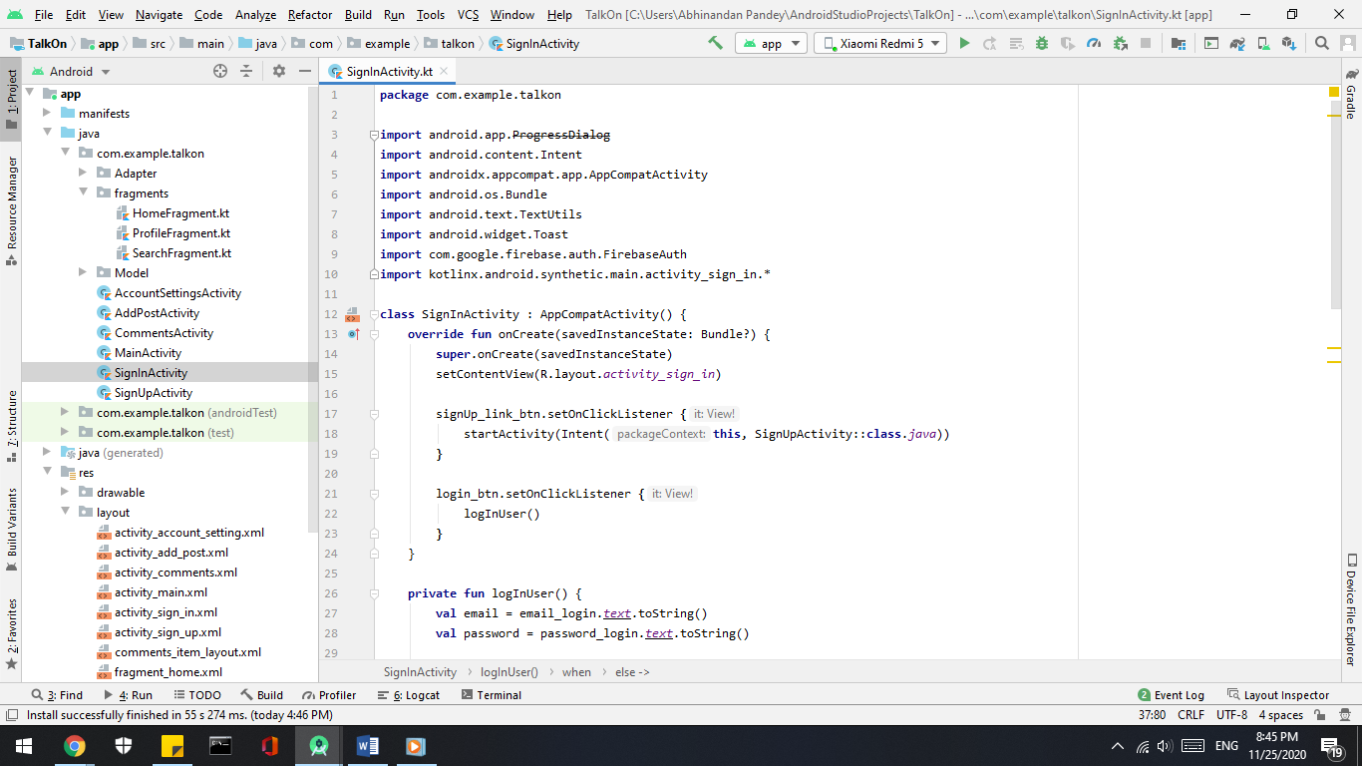

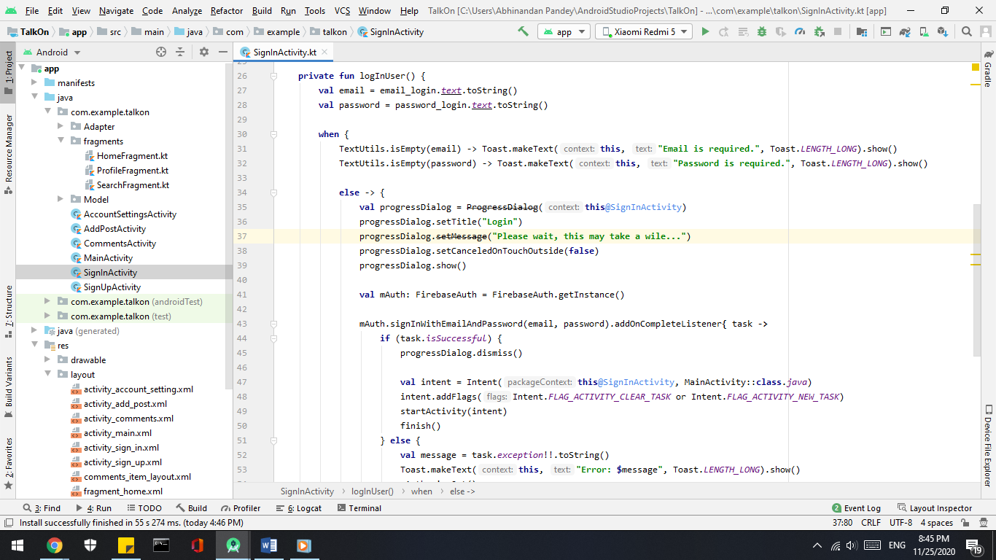

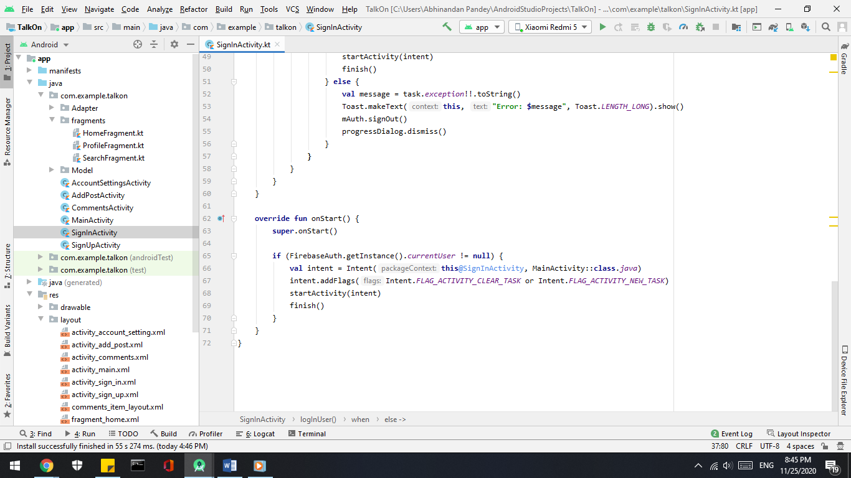

* **Home -**
  + **Frontend**

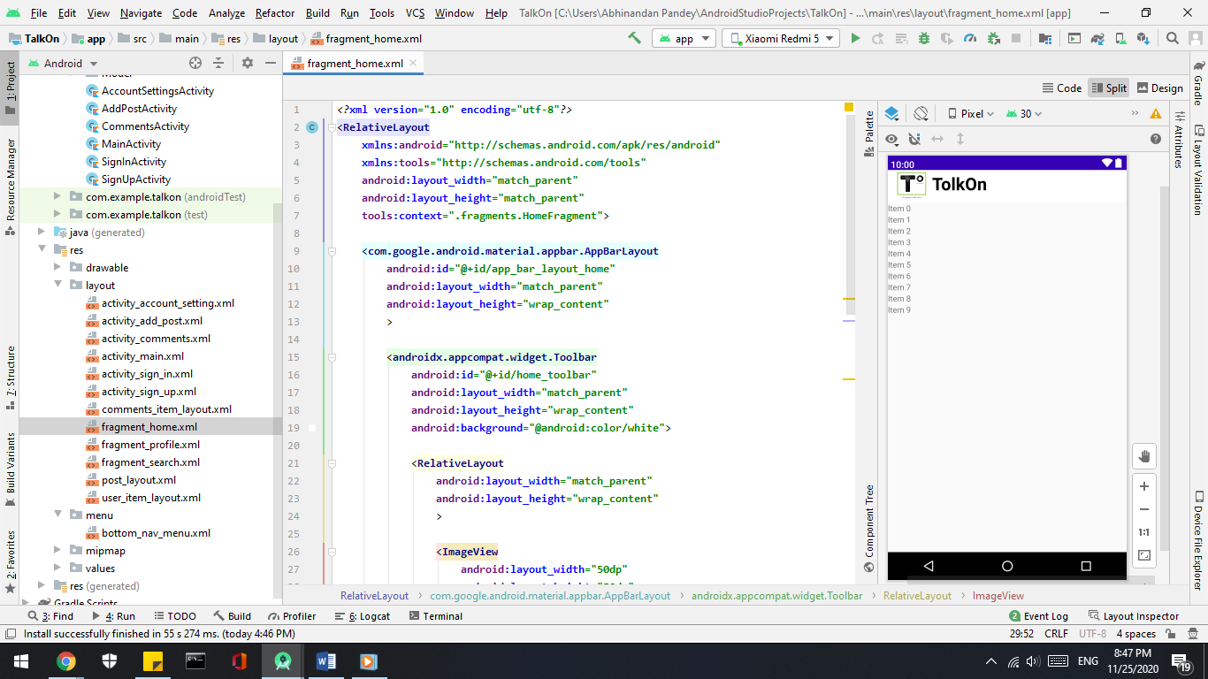

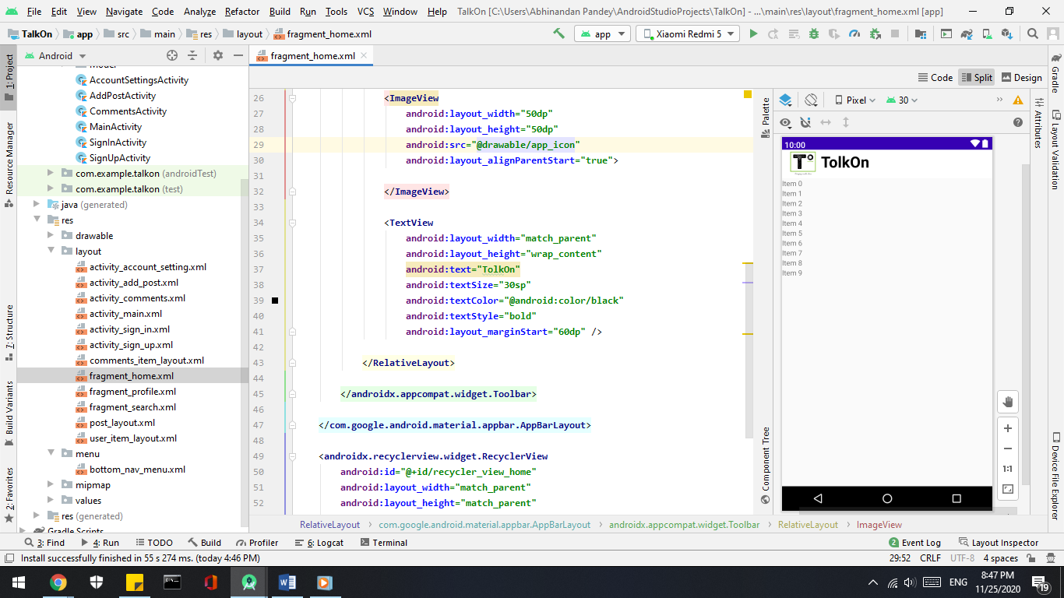

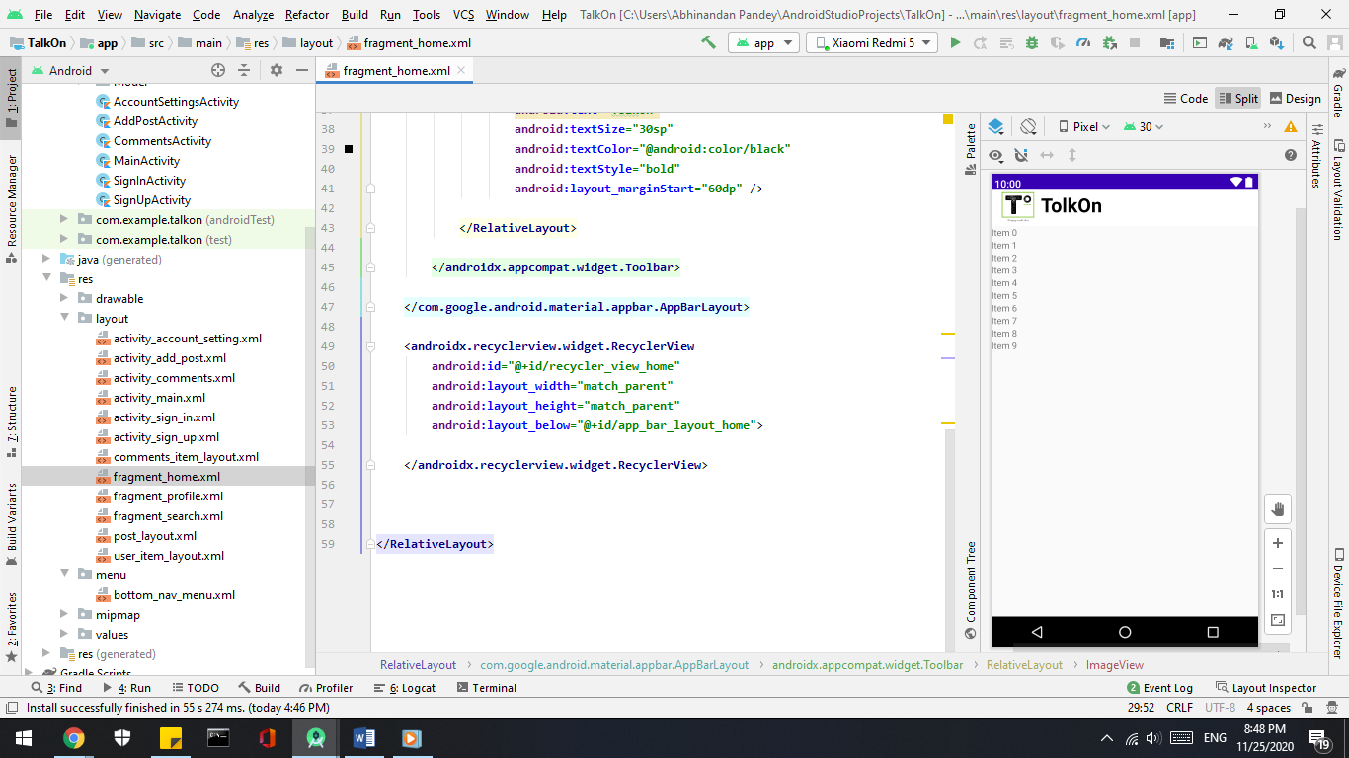

* + **Backend**

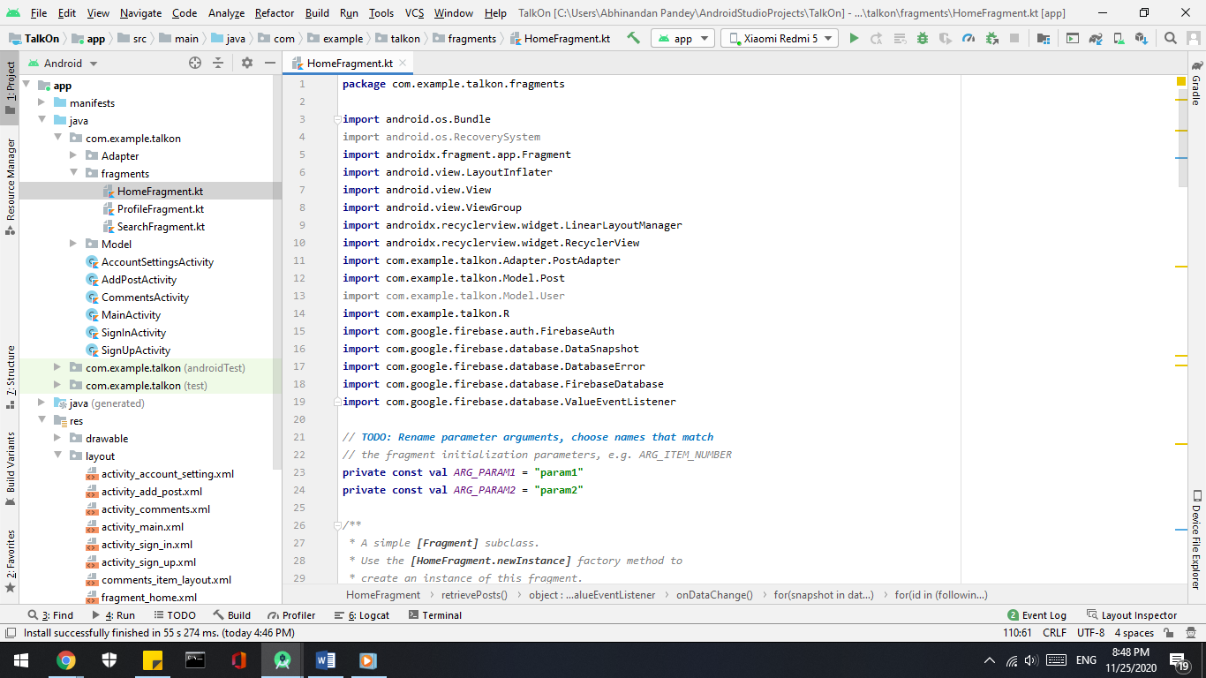

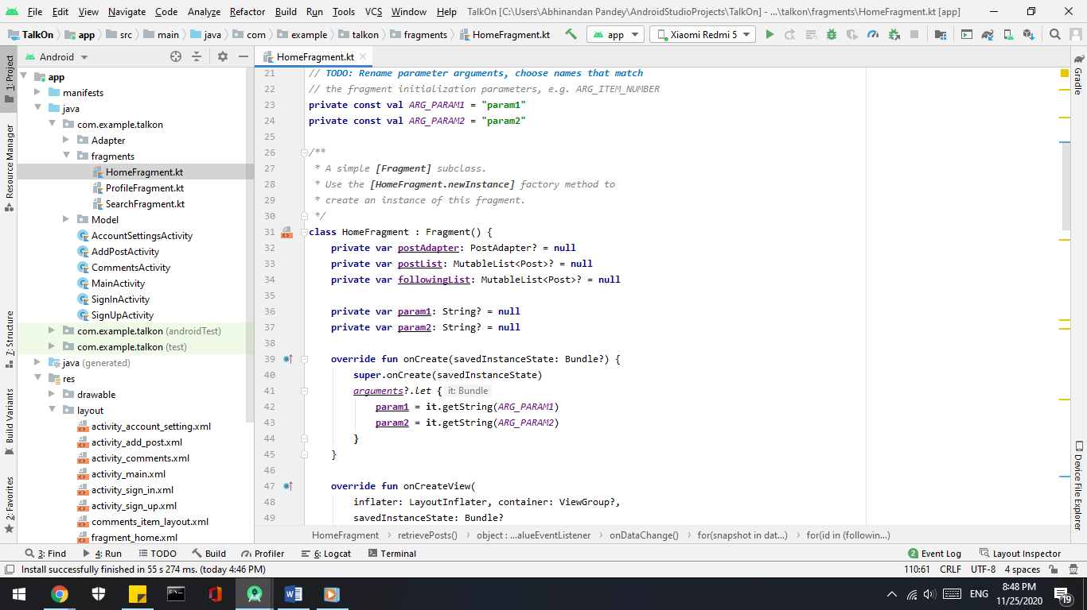

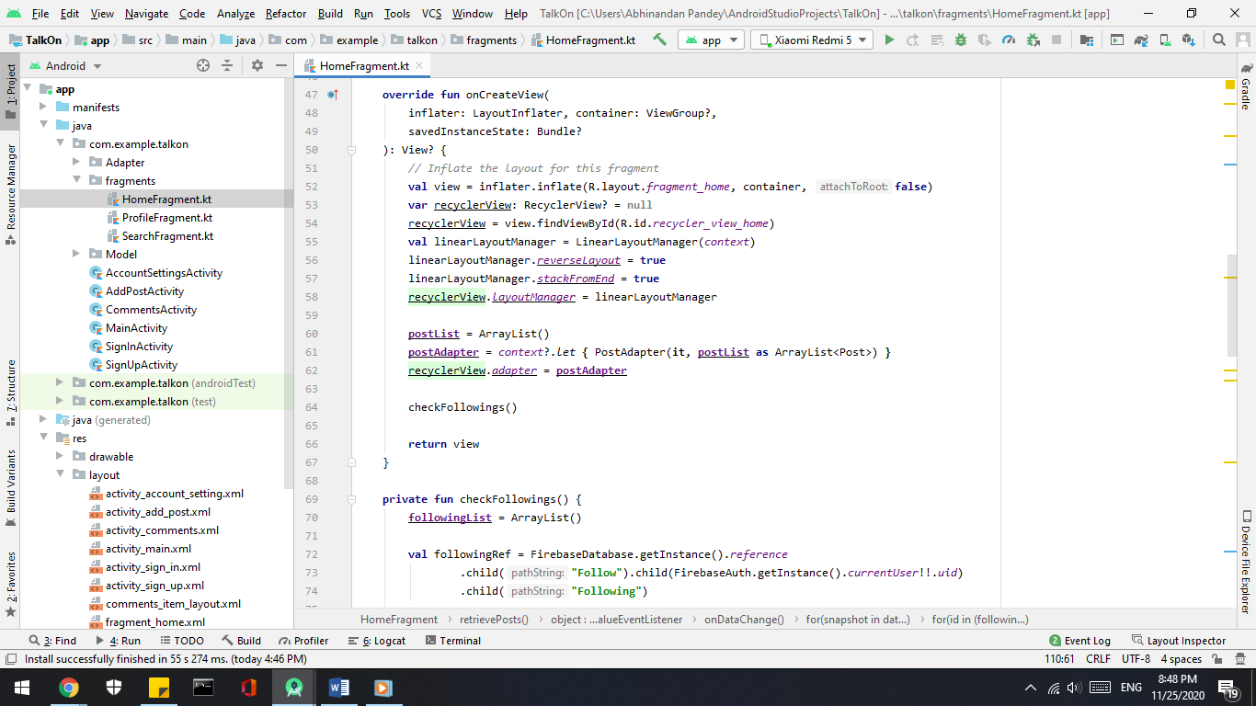

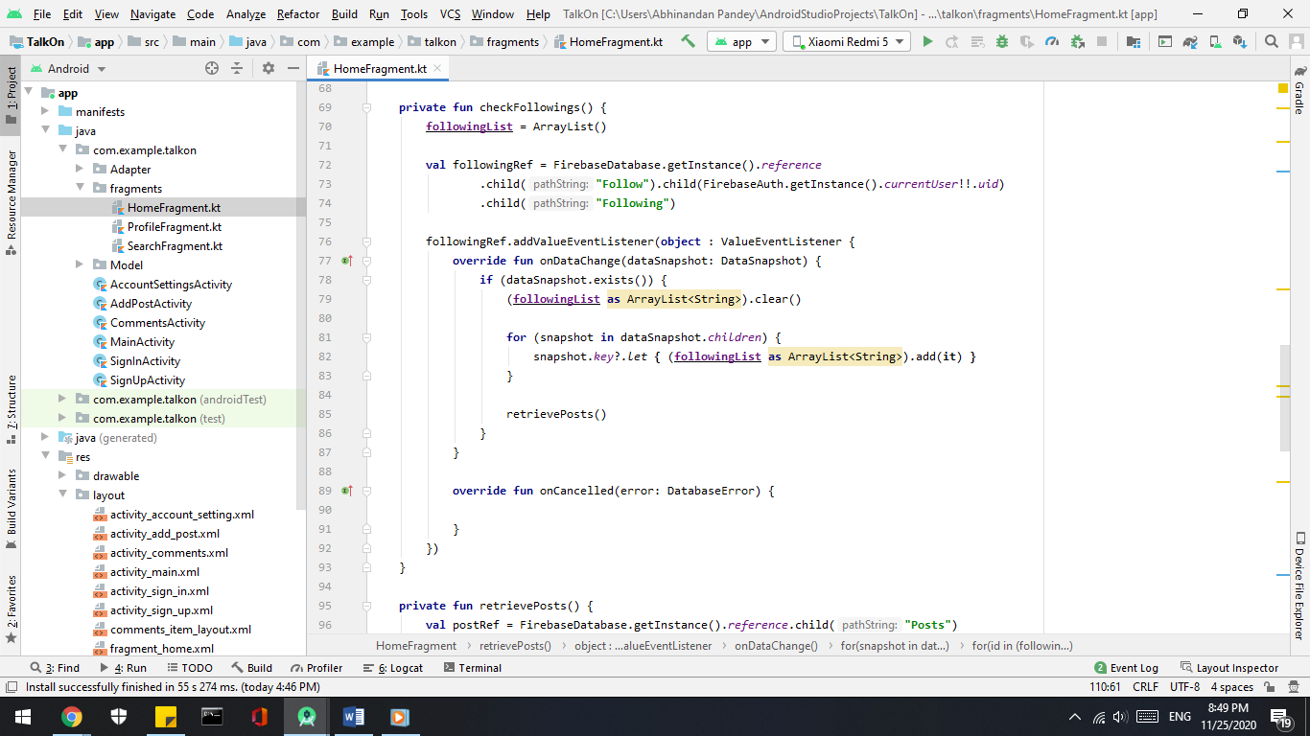

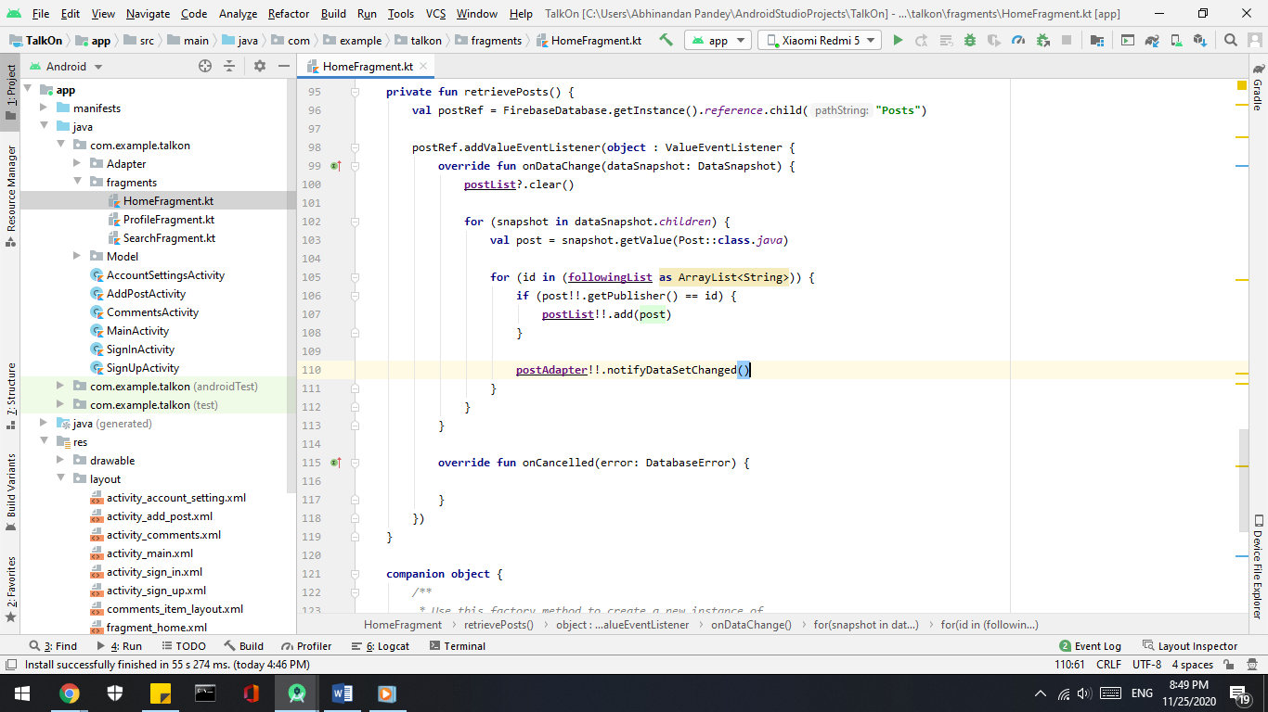

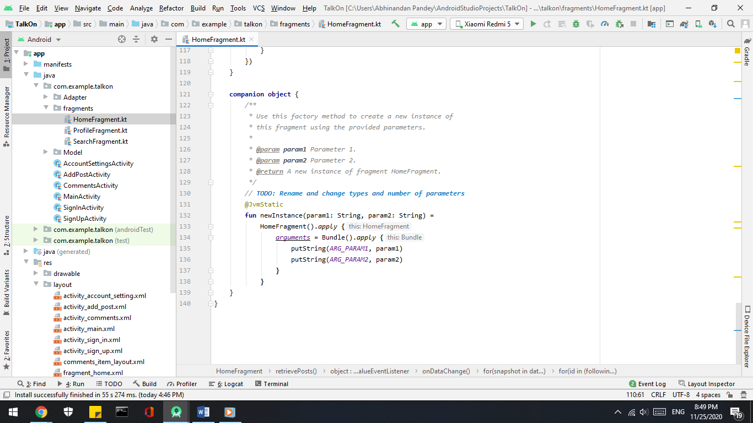

* **Search –**
  + **Frontend**

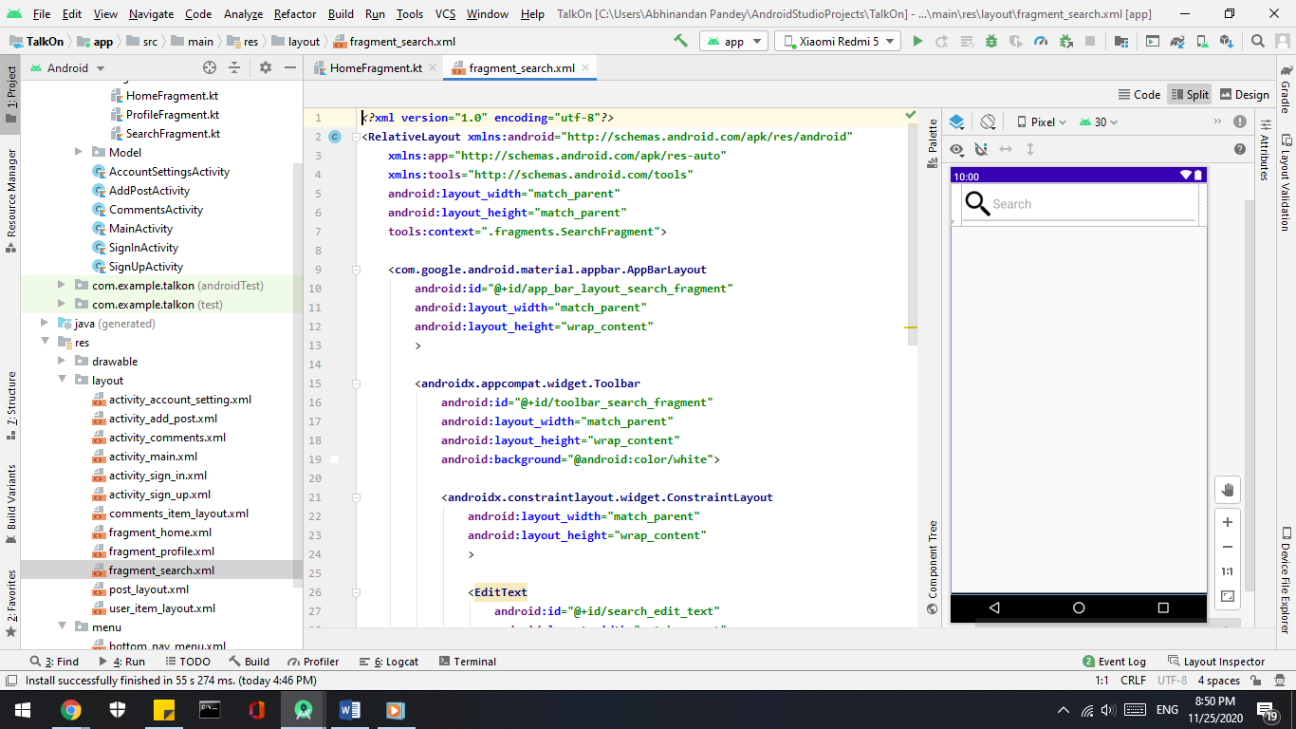

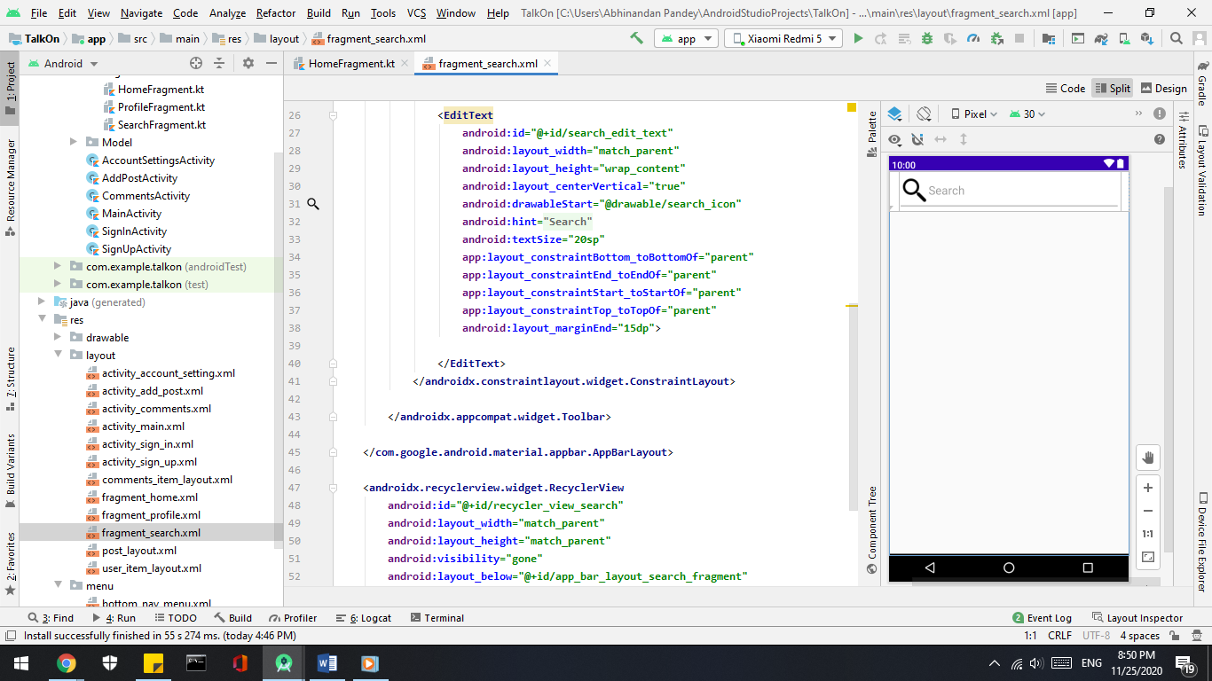

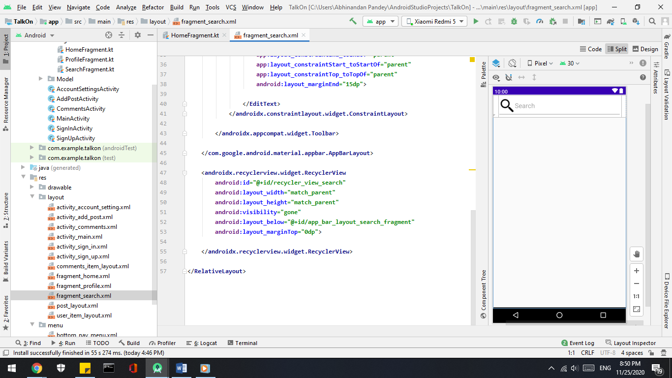

* + **Backend**

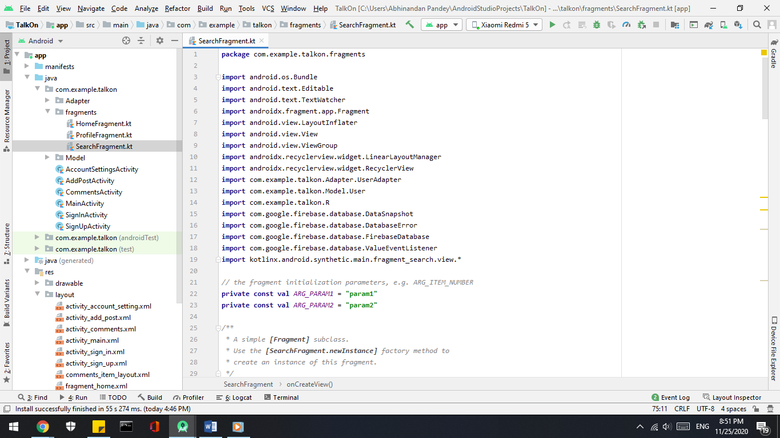

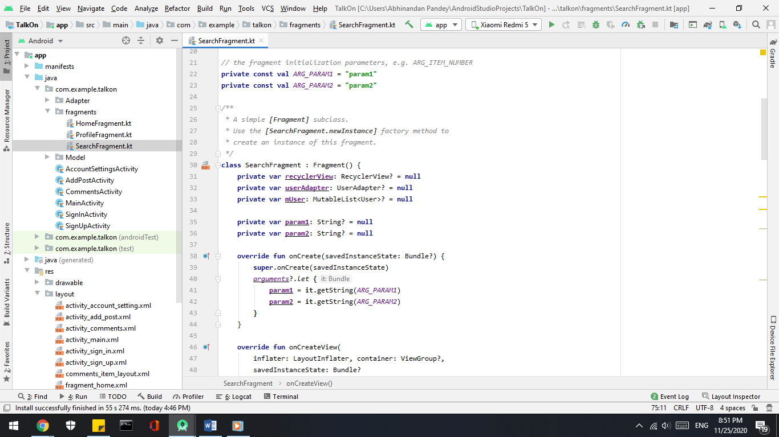

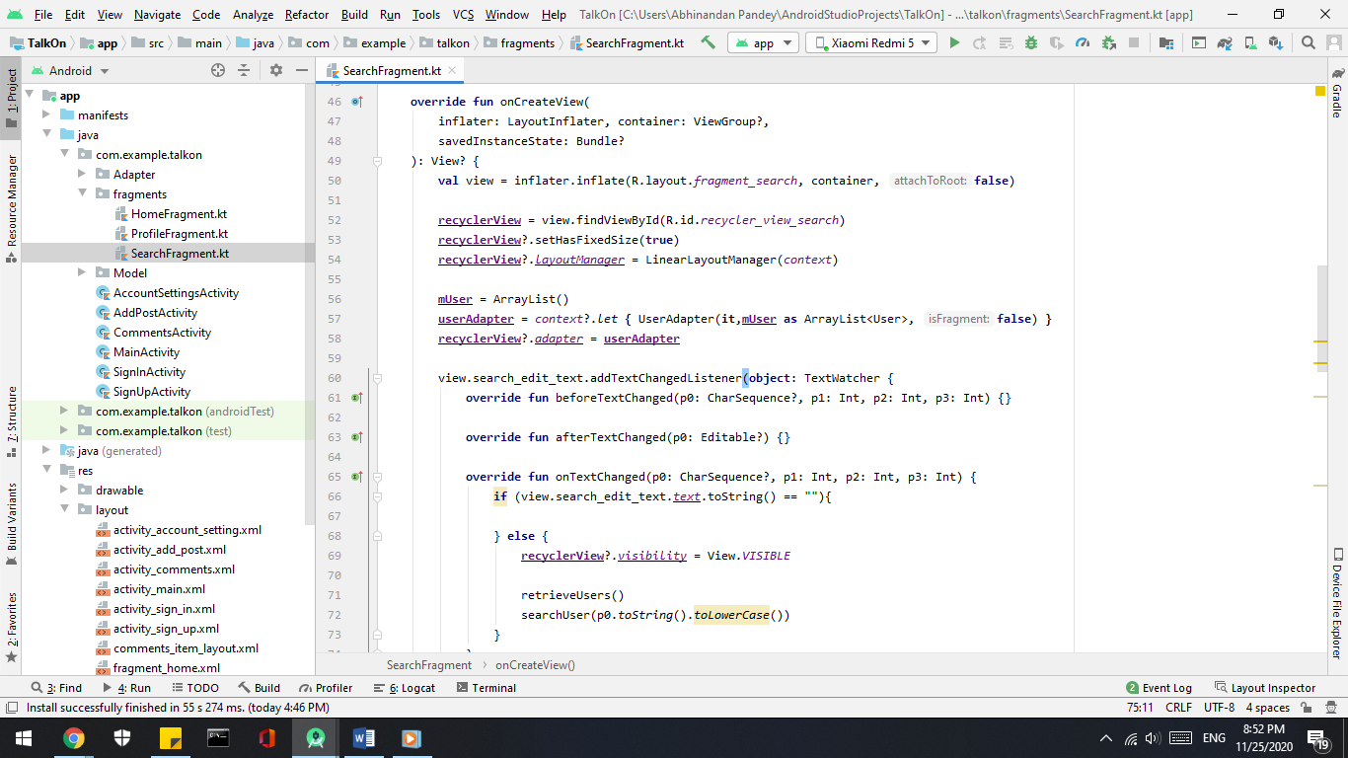

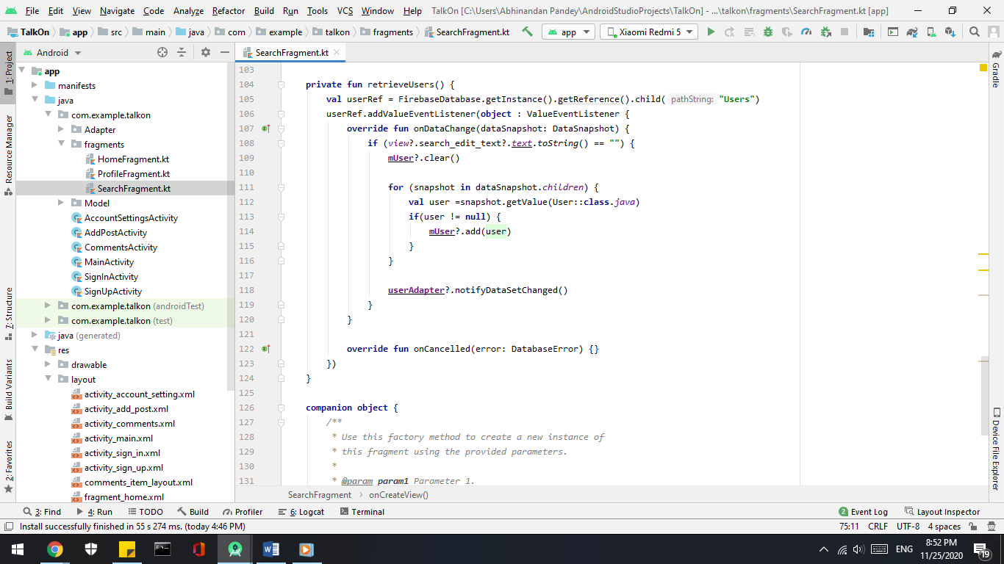

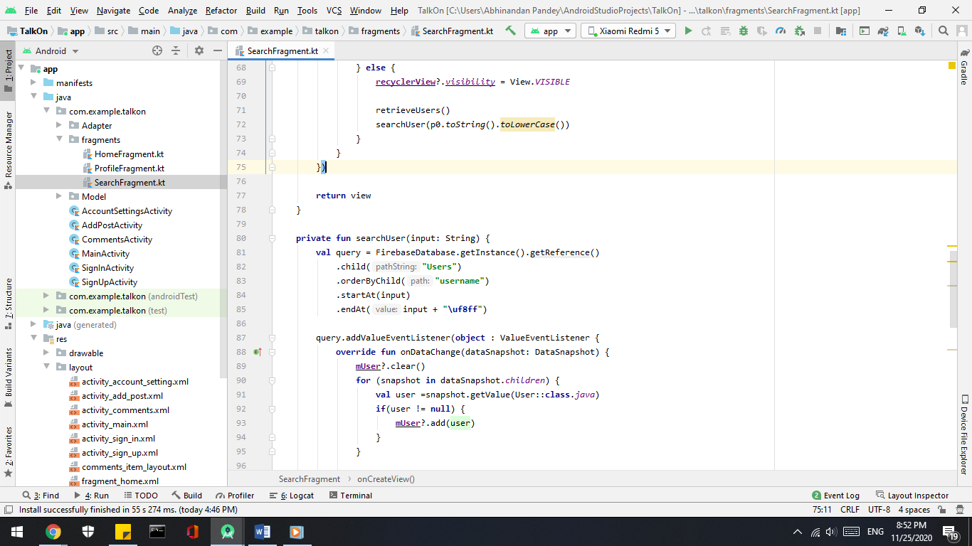

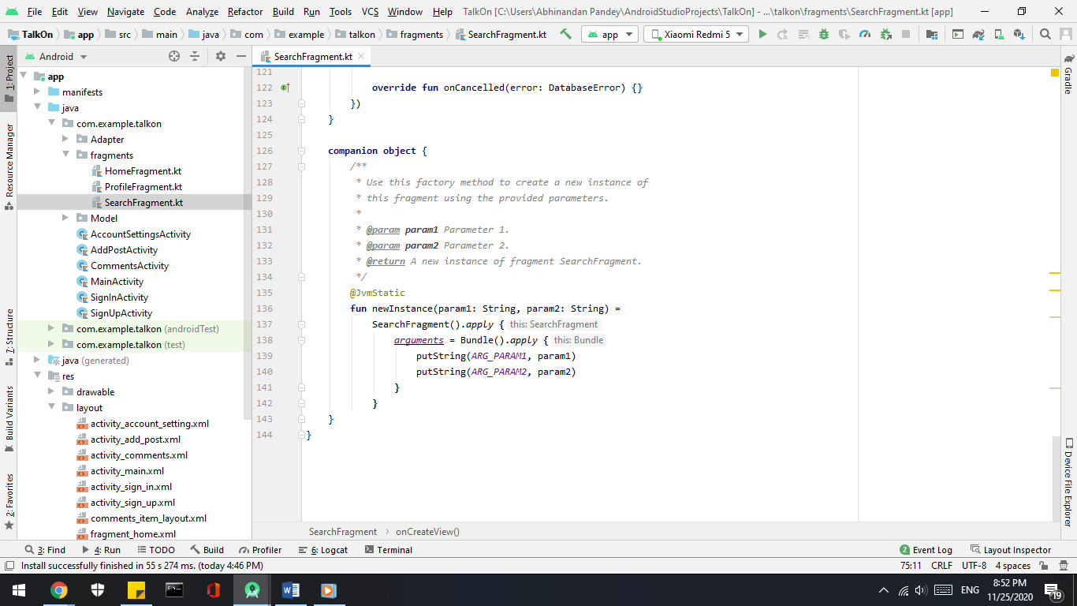

* **Profile –**
  + **Frontend**

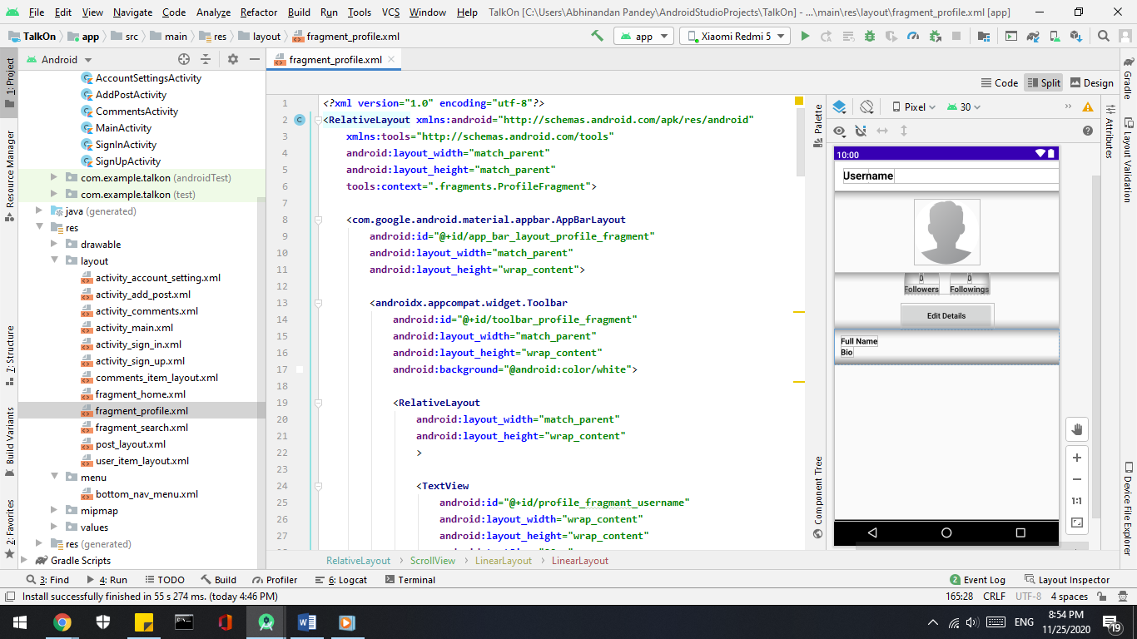

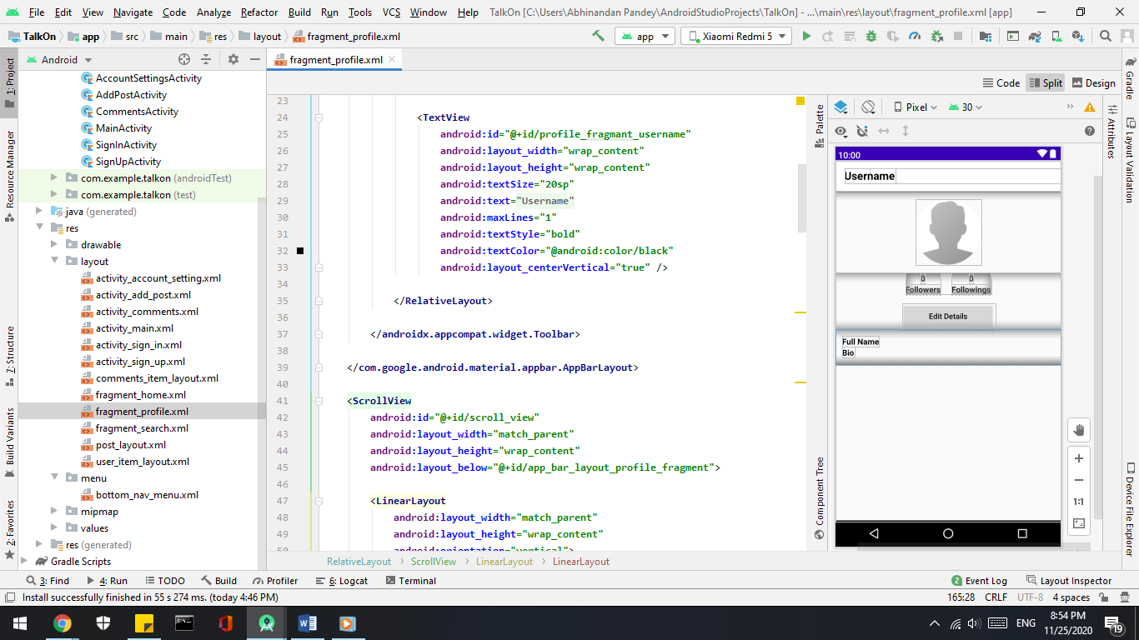

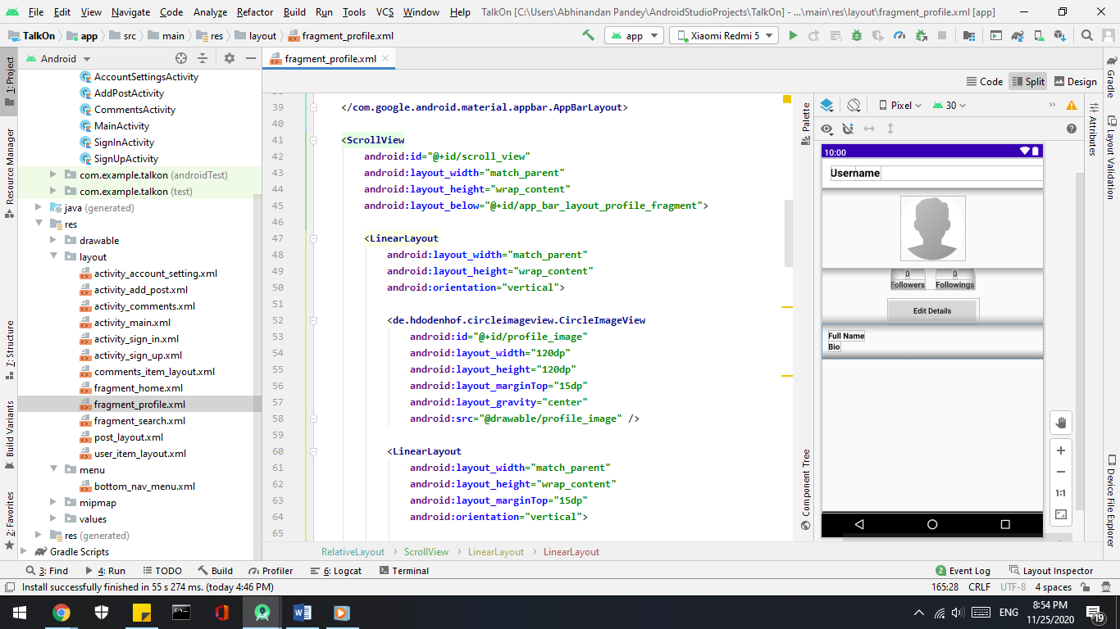

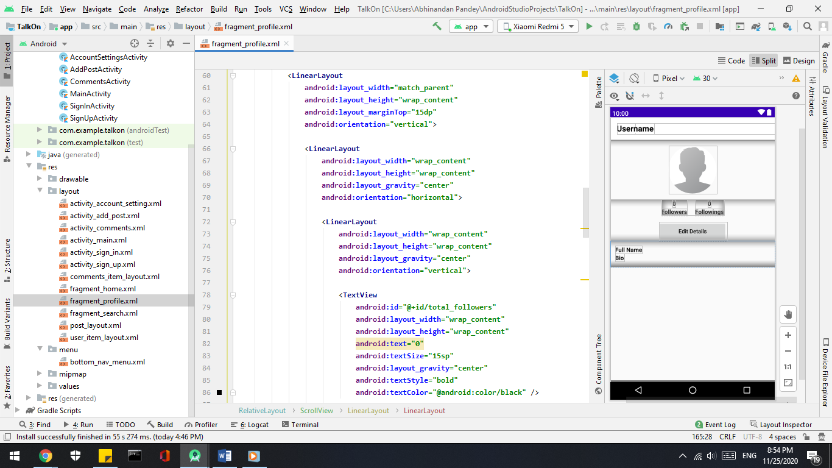

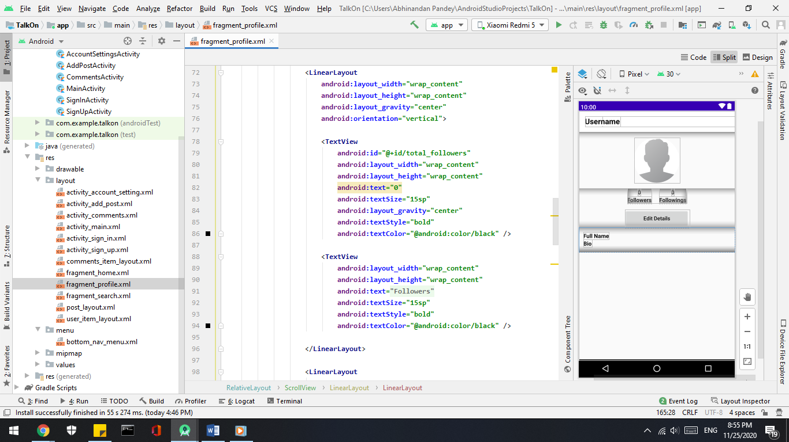

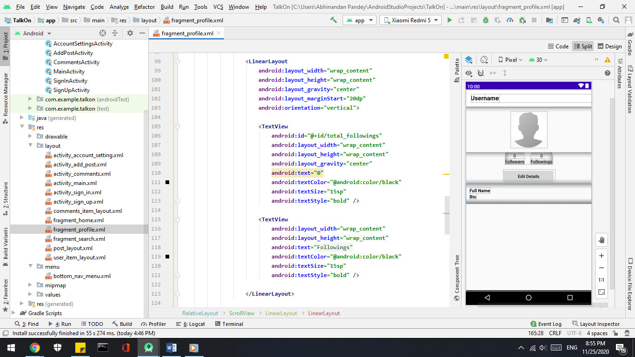

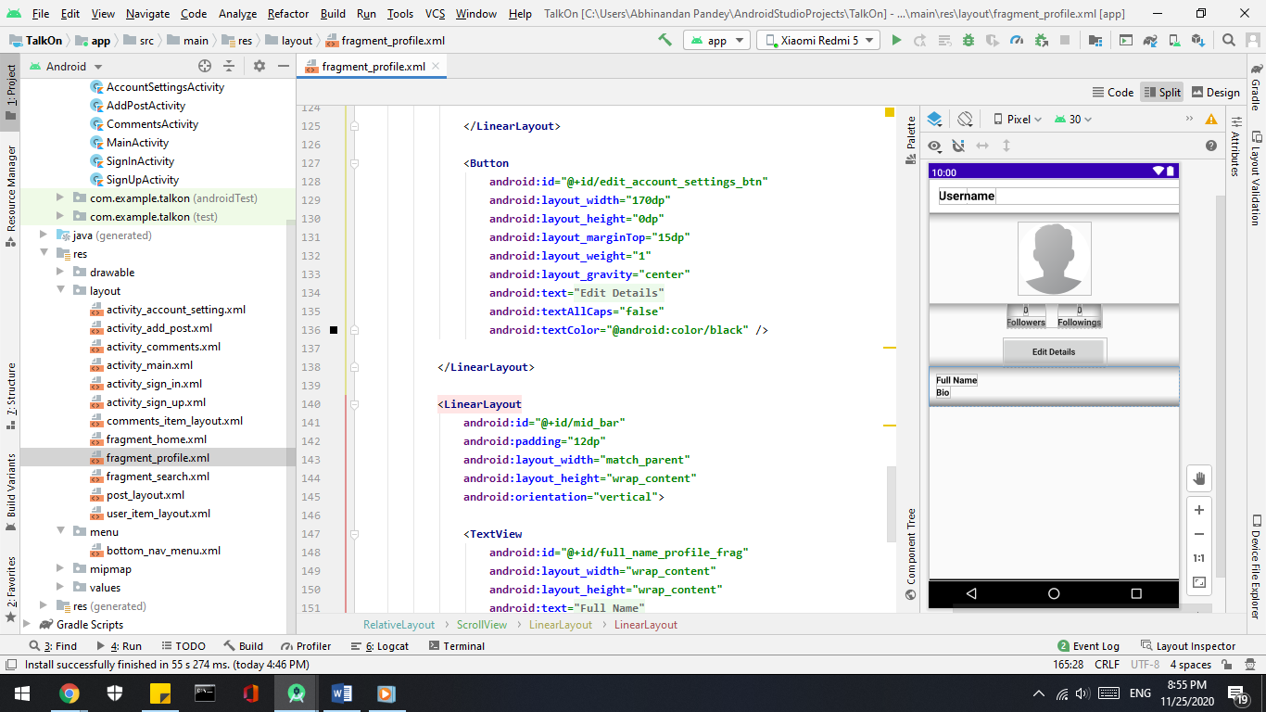

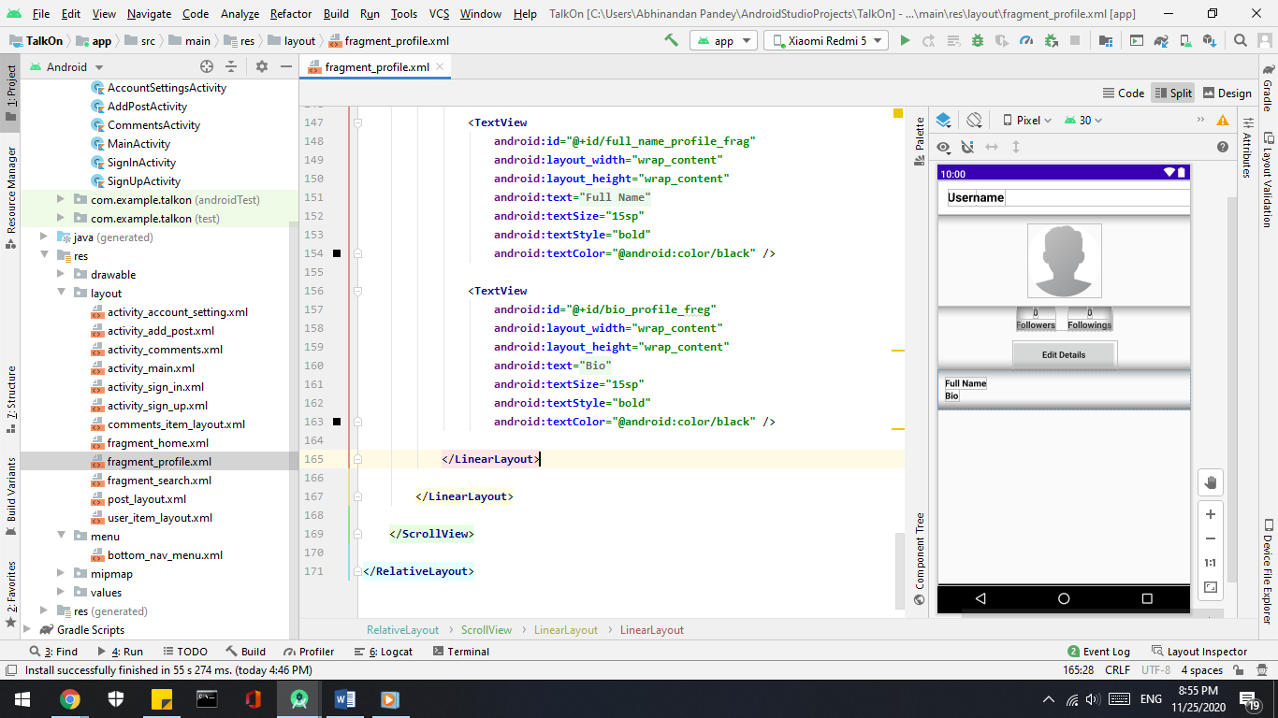

* + **Frontend**

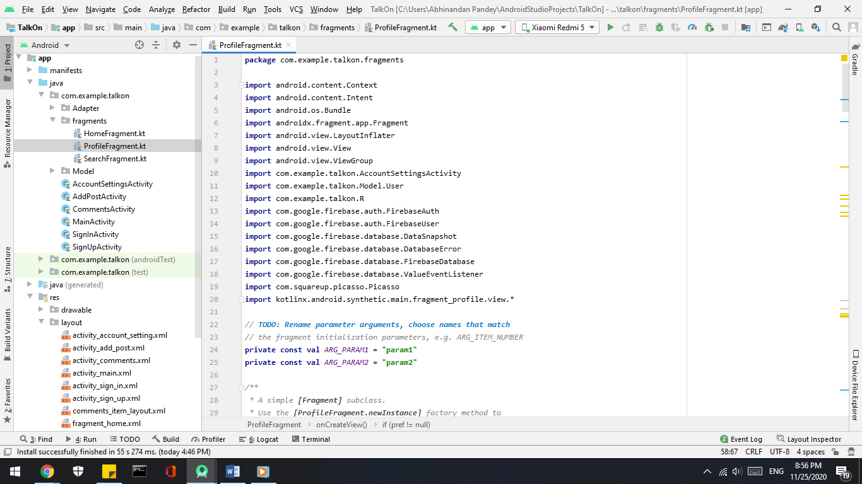

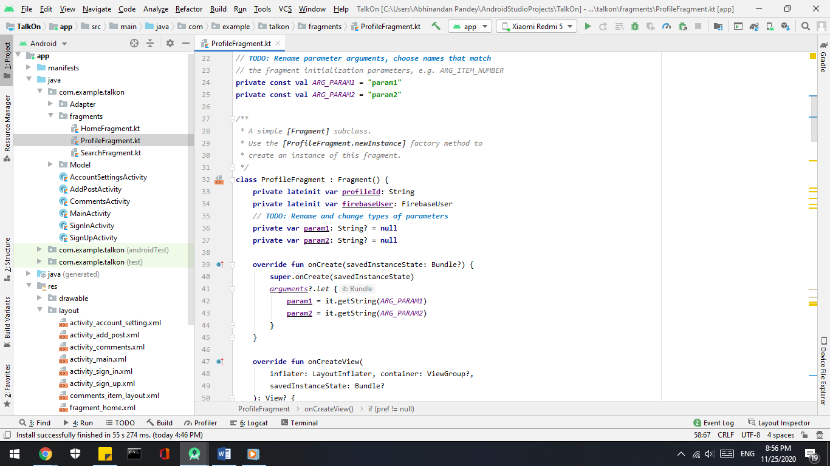

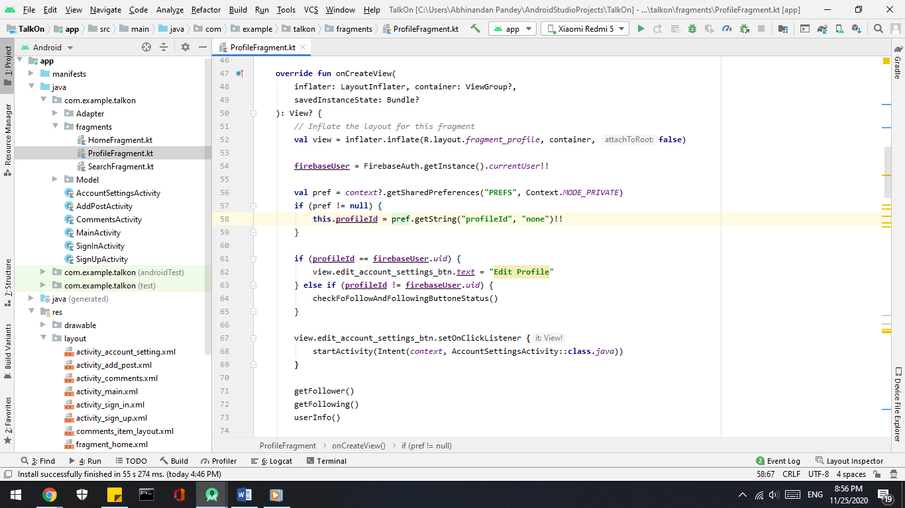

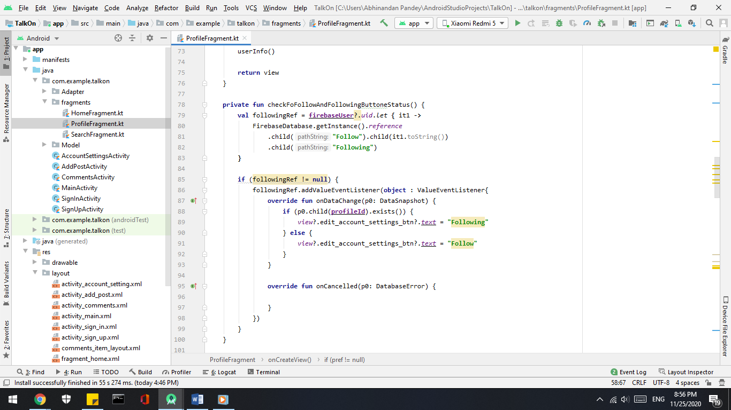

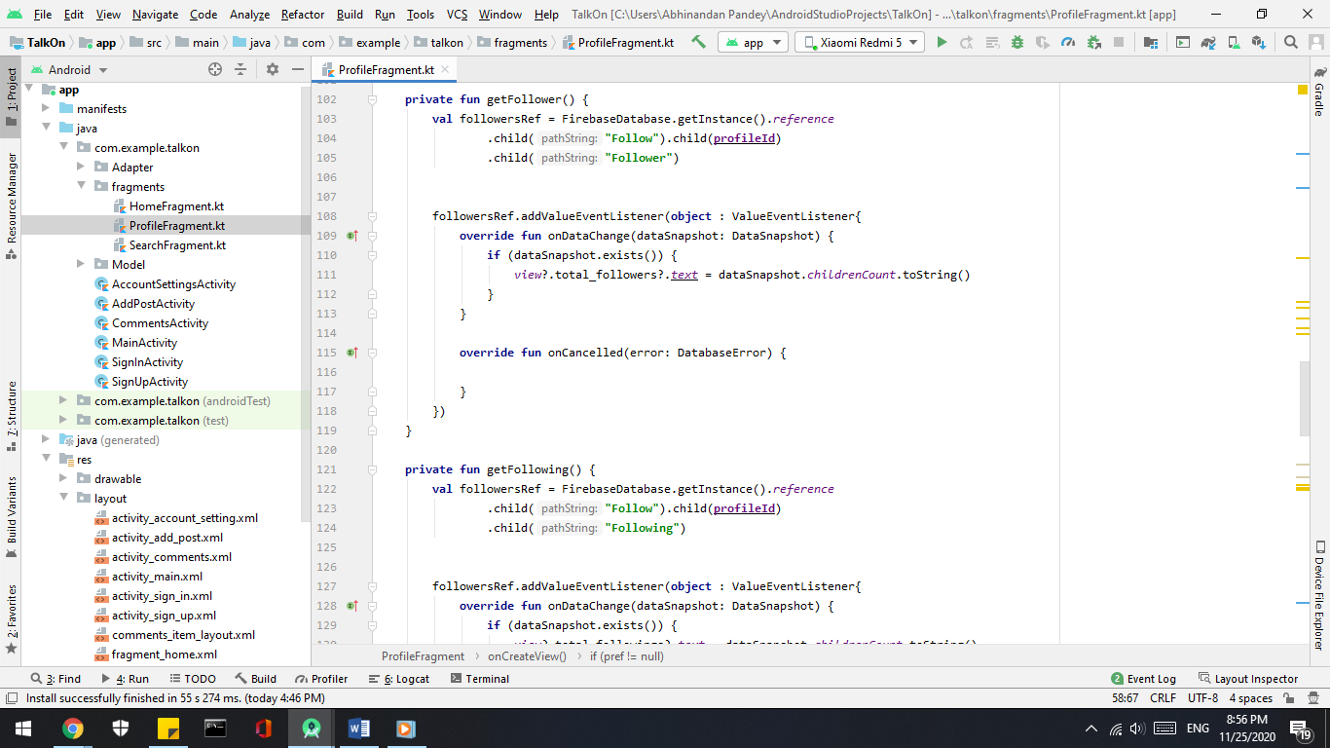

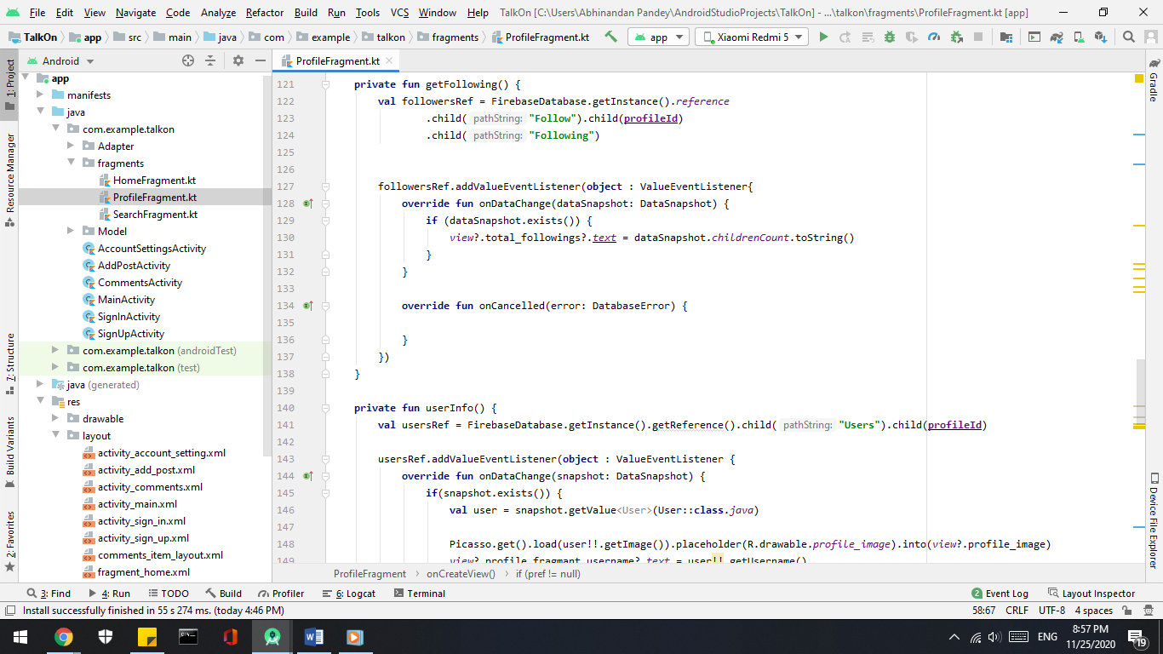

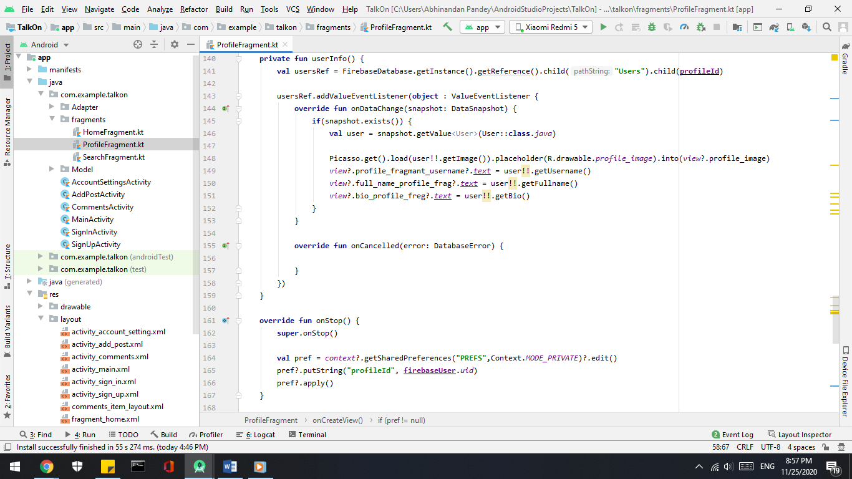

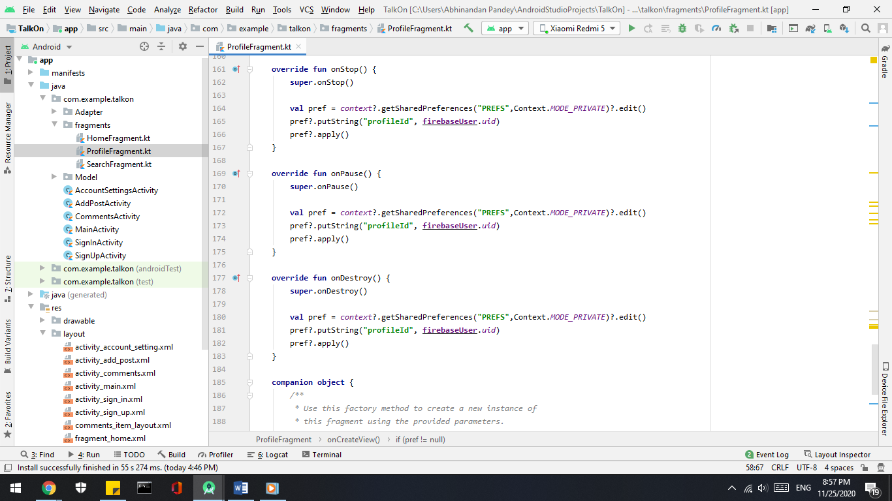

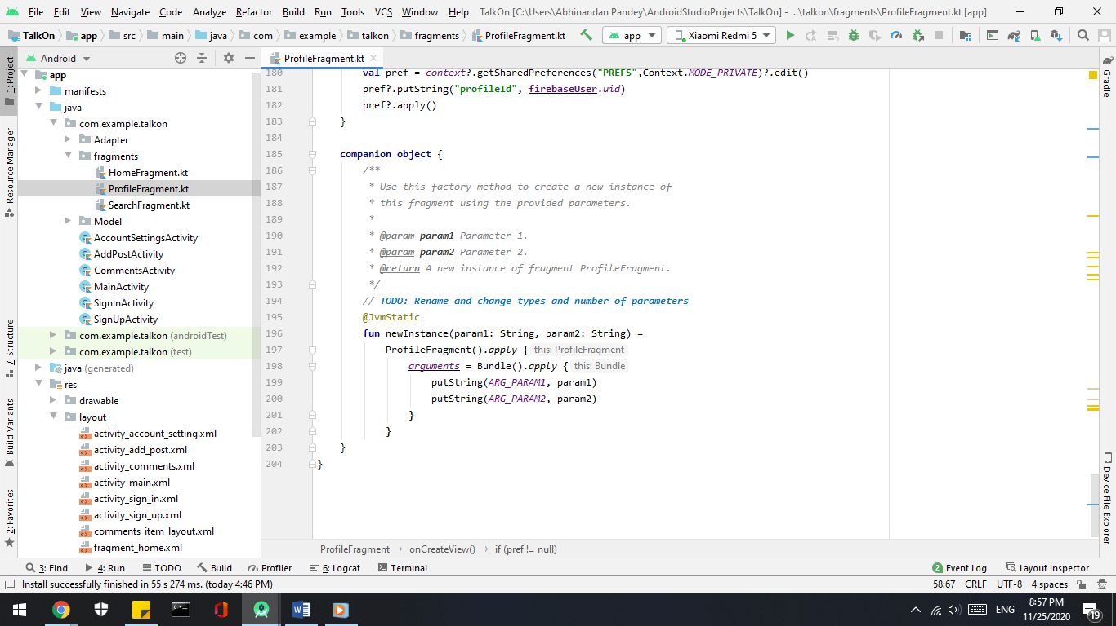

**Screenshots of Code**



